Horizon Europe Framework Programme


OPTICAL 6G CELL FREE NETWORKS

______________________________________________________

D4.1: OWC Localization Sensing System Design
Contractual Delivery Date: | M12
Actual Delivery Date:
Editor: (name, organization) | Israel Koffman - RunEL
Deliverable nature: | R/P
Dissemination level: | PU
Version:
Keywords: OWC, Localization, Positioning, Cellfree, 5G, B5G, 6G
ABSTRACT
This deliverable presents accurate positioning techniques applicable for emergency systems, commercial and industrial (industry 4.0) innovative systems.
This document includes the system design of 3 advanced methods for OWC-based localization sensing.
These methods include:
- ToA, TDoA, PoA or PDoA
- RSS based localization
- Beam-steering-based localization by modulation of the orientation of optical sources
A localization fusion server to enhance the localization performance and reliability is also included.
The design refers to solutions architecture, KPIs, risks and tests principles and methods.

Disclaimer
This document contains material which is the copyright of certain OPTI-6G consortium parties and may not be reproduced or copied without permission.
The information contained in this document is the proprietary confidential and sensitive information of the OPTI-6G consortium and may not be disclosed except in accordance with the grant agreement and consortium agreement.
Neither the OPTI-6G consortium, nor a certain part of the OPTI-6G consortium, warrant that the information contained in this document is capable of use, nor that use of the information is free from risk, accepting no liability for loss or damage suffered by any person using this information.

This project has received funding from the European Union’s Horizon Europe research and innovation programme under grant agreement No 101139292. This publication reflects only the author’s view, and the European Commission is not responsible for any use that may be made of the information it contains.

Impressum
Full project title: OPTICAL 6G CELL FREE NETWORKS
Short project title: OPTI-6G
Number and title of the work package: WP4- OWC Localization Sensing
Number and title of tasks: Task-4.1: OWC TDoA Localisation Sensing, Task-4.2: OWC RSS and AoA Localisation Sensing and Task 4.3: Integration and Testing of Optical Location Systems:
Document title: D4.1 – OWC Localization Sensing System Design
Editor: Israel Koffman RunEL NGMT Ltd, Israel
Work-package leader: John Cosmas, Brunel University, UK

Copyright notice
2024 Eurescom GmbH and members of the OPTI-6G consortium

Executive summary
Accurate positioning is applicable to a plurality of applications and services, these include emergency systems, commercial (e.g., autonomous driving) systems and industrial (industry 4.0) innovative solutions.
This document covers the system design of 3 advanced methods for OWC based localization sensing.
These methods include:
- ToA, TDoA, PoA or PDoA - measuring the ToA, TDoA, PoA or PDoA of one or several signals sent by one or several Aps. The general idea behind these methods is to measure accurately the signals end-to-end timing and by trilateration, it is eventually possible to find the coordinates of the UE.
- RSS based localization is an essential metric for localization in various communication systems. The key in this method is assessing the power of the signal received by an antenna or photodetector. RSS-based localization estimates the position of a user or object by analyzing the signal power received from multiple light sources.
- The 3rd method is an innovative method based on the modulation of the orientation (AoA) of optical sources. By associating an optical source with a UE equipped with a PD which orientation can be modulated. By applying four different rotations to this PD, it is then possible to perform RSS-based 2D positioning with cm-level accuracy, without the need to know the transmitted optical power. We exploit the beam-steering possibility, to modulate the orientation of a source to gain a new hybrid RSS and AoA positioning method, where only one pair of AP-UE is needed for 2D positioning (instead of at least three APs in the state-of-the-art) and two APs are needed for 3D positioning.
A localization fusion server which fuses the 3 methods results is also designed to enhance the localization performance and reliability.

List of authors
Company | Author | Contribution
RunEL | Israel Koffman, Baruch Globen | ToC, Chapter 2,3,7, Editing
Brunel University | John Cosmas, Ali Mahbas, Kareem Ali | Introduction, Chapter 4,6
Oledcomm | Clement Lartigue | Chapter 5
UVSQ | Bastien Béchadergue | Chapters 2,3,4,5

Document History
Version | Date | Editor | Description
0.1 | 22/07/2024 | Israel Koffman | Template and ToC
0.2 | 10/12/2024 | Israel Koffman | Final version for review
0.3

Table of Contents
Executive summary 3
List of authors 4
Document History 4
Table of Contents 5
List of figures and tables 7
1 Introduction 10
1.1 Introduction 10
1.2 Objective of this document 10
1.3 Structure of This Document 10
2 UE Localization Methods: Background and State-of-the-Art 12
2.1 About the Need for Accurate UE Localization 12
2.2 Optical Wireless Positioning: A brief State-of-the-Art 13
2.2.1 Overview of the state-of-the-art 13
2.2.2 Generic modeling of an OWP system 16
2.2.3 T(D)OA and P(D)OA-based techniques 18
2.2.4 RSS and AOA-based techniques 18
2.3 Positioning of OPTI-6G Compared to the State-of-the-Art 22
3 UE Localization Sensing based on Time of Arrival measurements 23
3.1 Theoretical basis 23
3.2 Localization System Architecture 24
3.3 Localization System Design 27
3.4 Target KPIs 27
3.5 Potential Risks 28
3.6 Tests Principles and Test Plans 28
4 UE Localization Sensing based RSS measurements 29
4.1 Theoretical basis 29
4.1.1 Fingerprinting 29
4.1.2 Artificial Neural Networks (ANN) for Localization 31
4.2 Localization System Architecture 33
4.3 Localization System Design 35
4.4 Target KPIs 37
4.5 Potential Risks 38
4.6 Tests Principles and Test Plans 38
5 UE Localization Sensing based on the Modulation of the Orientation of Optical Sources 39
5.1 Introduction 39
5.2 Theoretical basis 40
5.2.1 Assumptions and Modelling 40
5.2.2 Core Principles of the Proposed Positioning Method 43
5.2.3 Case of a Single Lambertian Source 44
5.2.4 Case of Two Lambertian Sources 46
5.2.5 Conclusions and Important Notes 47
5.3 Localization System Architecture 48
5.4 Localization System design 49
5.5 Target KPIs 51
5.6 Potential Risks 51
5.7 Tests Principles and Test Plans 52
6 Localisation Methods Fusion Server 54
6.1 Localisation Fusion System Architecture 54
6.2 Location Database 54
6.3 Localisation Interfaces between AOA, ToA, RSS sensors and Database 56
6.4 Graphical User Interface to Localisation 57
6.4.1 Remote access to Openstack & MySQL Database Linux Servers 57
6.5 Localisation Fusion Methodologies 59
6.5.1 Uplink distance and location estimates using ToA and RSS measurements 59
5.6.2 Strategy for Localisation fusion using ToA and RSS data 61
6.6 Target KPIs 62
6.7 Potential Risks 62
6.8 Tests Principles and Test Plans 62
7 Summary 64

List of figures and tables
List of figures:
Figure 1: Main positioning technologies with their accuracy and usual applications. 16
Figure 2: Geometrical modelling of a generic OWP system. 20
Figure 3: RSS Localization in OWC System. 26
Figure 4: Hyperbola pattern crossing at the target UE position 28
Figure 5: UE location measurement based on TDoA trilateration 29
Figure 6: System General Block Diagram including UE Position Measurement 30
Figure 7: Accurate DToA processing 31
Figure 8: Distributed Antennae Positioning Architecture Diagram 31
Figure 9: OWC- Positioning Architecture Diagram 32
Figure 10: Fingerprint Algorithm 36
Figure 11: OWC System architecture in Brunel Lab. 41
Figure 12: Operation distance and coverage area. 42
Figure 13: Uplink (left) and downlink (right) data rates. 42
Figure 14: Example of testbed for RSS-based positioning performance evaluation. 45
Figure 15: Example of expected test results (2D positioning case). 47
Figure 16: Geometric configuration of the proposed system and notations (at the exception of the polar angles $θ1,i$ and $θ2,i$, not represented for the sake of readability). 50
Figure 17:Architecture of the OPTI-6G system including the proposed beam-steering-based OWP system (the up and down-converters are hidden and the central units are simplified to ease readability). 59
Figure 18: First test bench implemented to validate the proposed beamsteering-based OWP technique. 61
Figure 19: Example of expected test results (2D positioning case). 64
Figure 20: OWC and Sub 6 GHz antennas’ locations 65
Figure 21: x2go client 69
Figure 22: Creating x2go client 69
Figure 23: Access x2go client 70
Figure 24: x2go access to Openstack server 70
Figure 25: Measuring RSS from downlink transmissions at UEs 71
Figure 26: Extrapolation to counter measurements at different times 72
Figure 27: Measuring RSS from uplink transmissions at OWC antennas 72
Figure 28: Area of coverage area with LoS access to N access points, where 0 < N <=4 74

List of Tables:
Table 1: Overview of the state-of-the-art on experimental OWP and OWC-based ISAC (CDMA: Code division multiple access, DDM: Difference in depth of modulation, FBMC: Filter bank multi-carrier, ND: Non-defined, SC: Solar cell). 19
Table 2: Sub 6 GHz and OWC antennas’ locations 66
Table 3: Raw OWC data SNR, RSSI … 66
Table 4: Estimated UE’s location by using OWC using ToA 66
Table 5: OWC data and Reference location of UE 67
Table 6: Estimated UE’s location by using OWC using RSS 67
Table 7: Camera data and actual location 67
Table 8: LIDAR data and actual location 67

Abbreviations and Acronyms
2D | Two Dimensions
3D | Three Dimensions
3GPP | 3rd Generation Partnership Project
6G IA | 6G Infrastructure Association
ADC | Analogue to Digital Converter
AGV | Automated Guided Vehicle
AFE | Analogue Front End
AI | Artificial Intelligence
ANN | Artificial Neural Network
AoA | Angle of Arrival
AP | Access Point
AR | Augmented Reality
AWGN | Additive White Gaussian Noise
BS | Base Station
C-plane | Control plane
CDF | Cumulative Distribution Function
CDMA | Code Division Multiple Access
CFN | Cell-Free Network
CIR | Channel Impulse Response
CNN | Convolutional Neural Network
CU | Control Unit
DDM | Difference in Depth Modulation
DHCP | Dynamic Host Configuration Protocol
DMRS | Demodulation Reference Signal
DL | Downlink
DToA | Differential Time of Arrival (DToA = TDoA)
DU | Distributed Unit
EC | European Commission
EDT | Extreme Decision Tree
EU | European Union
FBMC | Filter Bank Multi-Carrier
FFT | Fast Fourier Transform
FNN | Feedforward Neural Network
FoV | Field-of-View
GB | Gradient Boosting
GNSS | Global Navigation Satellite System
GP | Gradient Process
ICAS | Integrated Communication and Sensing (ICAS=ISAC)
IMU | Intertial Measurement Unit
IoT | Internet of Things
IR | Infrared
ISAC | Integrated Sensing and Communication (ICAS=ISAC)
ISBN | International Standard Book Number
ISRC | International Standard Recording Code
ITU | International Telecommunications Union
IWKNN | Improved Weighted K-Nearest Neighbour
JU | Joint Undertaking
KNN | K-Nearest Neighbour
KPI | Key Performance Indicator
LCS | Localization System
LD | Location Database
LED | Light Emitting Diodes
LIDAR | Light Detection and Ranging
LoS | Line of Sight
LS | Location Server
MAC | Media Access Control
MIMO | Multiple-Input Multiple Output
ML | Machine Learning
MLP | Multi-Layer Perception
mMIMO | Massive Multiple-Input Multiple-Output
mmWave | Millimeter Wave
MWC | Mobile World Congress
ND | Not Defined
NLoS | Non-Line of Sight
O-RAN | Open-Radio Access Network
O-RU | O-RAN compliant Remote Unit
OFDM | Orthogonal Frequency Division Multiplexing
OFDMA | Orthogonal Frequency Division Multiple Access
OFE | Optical Front End
OWC | Optical Wireless Communication
OWP | Optical Wireless Positioning
PC | Personal Computer
PD | Photodetector / Photodiode
PDoA | Phase Difference of Arrival
PLC | Programmable Logic Controller
PoA | Phase of Arrival
PoE | Power over Ethernet
PRS | Positioning Reference Signal
RAN | Radio Access Network
RF | Radio Frequency / Random Forest
RMS | Root Mean Square
RNTI | Radio Network Temporary Identifier
RSS | Received Signal Strength
RU | Radio Unit
Rx | Receiver
SC | Solar Cell
SNS | Smart Networks and Services
SQL | Structured Query Language
SRS | Sounding Reference Signal
SVM | Support Vector Machine
TDoA | Time Difference of Arrival (DToA = TDoA)
ToA | Time of Arrival
Tx | Transmitter
UAV | Unmanned Arial Vehicle
UE | User Equipment
UL | Uplink
USRP | Universal Software Radio Peripheral
V2X | Vehicle to Others (X) communication
VLC | Visible Light Communication
VLP | Visible Light Positioning
VR | Virtual Reality
WKNN | Weighted K-Nearest Neighbour
WP | Work Package
XR | Extended Reality

Introduction

Introduction
This deliverable describes the design innovations of the localisation sensing systems developed in the OPTI-6G.

Objective of this document
This document covers the general specification for the OWC localisation systems. It provides general architecture and detailed building blocks structure of the TDoA, ToA, RSS, AoA and ToA/RSS fusion localisation systems. It presents the KPIs expected to be achieved for each type, the potential risks in achieving them and test principles and plans required to obtain them.

Structure of This Document
In section 2 the need to provide accurate localization in an OWC cell free network is presented. It also provides a brief literature survey of the state of the art of OWC localization methods and the theory of localization technology. It refers to the Technical Specification Group Services and System Aspects of the 3GPP TS 22.261 V19.6.0 (2024-03), Technical Specification 3rd Generation Partnership Project, which has identified enhanced service requirements for the 6G system positioning accuracies and location-based services required by new services in vertical industries. A brief overview of the state of the art of OWC positioning techniques is then presented and the PD-based ToA, RSS and AoA OWP positioning techniques developed in the OPTI-6G project identified. The theories, technological challenges and advantages/disadvantages behind ToA, RSS and AoA techniques are then presented.

In section 3 the theory behind TDoA and ToA is outlined and the capabilities of the technology principles capable of measuring time intervals with a resolution of 0.3 picoseconds, which corresponds to less than a centimeter ranging, is briefly explained. The system architecture enhancements required to convert a private commercial 5G sub 6GHz system to a 5G OWC system is presented. The experimental setup consists of a known location fixed UE which is used to calibrate the processing and a moving UE which is used for making positioning measurements. The network parameters required making distance measurements in the experimental setup and the expected for making measurements and the target measurement KPIs and potential risks identified.

In section 4 RSS-based fingerprinting localization in OWC systems is presented, which uses the RSS at various points in an environment to create a “fingerprint” of the location. The fingerprinting typically involves collecting RSS data from light sources (e.g., LEDs) at different positions in the area of interest. The two main phases of the RSS fingerprinting process in OWC systems are described, which involves the offline phase (training) and the online phase (testing or real-time localization). The theory and process of training for localisation of the Artificial Neural Networks (ANNs) is presented. The system architecture, example testbed, test procedures and expected results are presented.

In section 5 a fully new hybrid RSS and AoA positioning method is proposed, which modulates the orientation of a source by beam-steering to estimate position from only one pair of AP-UE for 2D positioning instead of at least three APs in the state-of-the-art) and two APs are needed for 3D positioning. Theory is presented which shows that by orienting the optical source of the AP in three different directions, and assuming that the z coordinate of the UE is known, it is then possible to estimate its remaining coordinates x and y, regardless of the transmitted optical power and the orientation of the UE. Theory is also presented which in the case where there are two APs, and therefore two optical sources are used, then it is possible to estimate its remaining coordinates x and y, regardless of the transmitted optical power and the orientation of the UE without assuming that the z coordinate of the UE is known. The system architecture for performing the location estimation experiments is presented with their expected KPIs and potential risks in obtained them.

In section 6 the OWC localisation fusion system architecture is presented for fusing ToA and RSS localisation data. The localisation fusion architecture, databases and Python packages and software required to access them are presented. How to install and use x2go remote access client required to remote access to the Dell 730 OpenStack Server and the Dell 740 RAN Host and SQL database is then presented. Justification and methodology of fusing ToA and RSS localisation data is then presented, followed by the KPIs expected to be achieved, the potential risks in achieving them and test principles and plans required to obtain them.

UE Localization Methods: Background and State-of-the-Art

About the Need for Accurate UE Localization
As the aim of the OPTI-6G project is to develop an OWC-based cell-free network, were the UEs communicate simultaneously with multiple Access Points (AP), it is absolutely vital to be able to estimate the location of the various UEs with a high degree of accuracy in order to know which UEs are under certain AP coverage area and to direct the AP antenna beams to towards the UEs.
Furthermore, in practice, accurate positioning is applicable to a plurality of applications, these include emergency systems, where having accurate location of an emergency caller is imperative to provide a fast response as well as for commercial (e.g., autonomous driving) and industrial (industry 4.0) applications and services.
In addition to this, with the emergence of the Internet of Things (IoT) and Integrated Communication and Sensing (ICAS) and more the positioning of the end terminal is essential for these novel systems.
3GPP TS 22.261 V19.6.0 (2024-03), Technical Specification 3rd Generation Partnership Project; Technical Specification Group Services and System Aspects; Service requirements for the 5G system; (stage 1, Release 19) describes this by the following:
5G positioning services aim to support verticals and applications with positioning accuracies better than 10 meters, thus more accurate than the ones of TS 22.071 [3GPP document- “Location Services (LCS); Service description; Stage 1”] for LCS. High accuracy positioning is characterized by ambitious system requirements for positioning accuracy in many verticals and applications, including regulatory needs.
In Location-Based-Services and eHealth, higher accuracy is instrumental to new services and applications, both outdoor and indoor. For example, on the factory floor, it is important to locate assets and moving objects such as forklifts, or parts to be assembled. Similar needs exist in transportation and logistics, for example rail, road and use of UAVs. In some road user cases, UE's supporting V2X application(s) are also applicable to such needs. In cases such as guided vehicles (e.g. industry, UAVs) and positioning of objects involved in safety-related functions, availability needs to be very high.
Mission Critical Organizations require services providing accurate positioning such that first responders can be located at all times during normal and critical operations, indoors as well as outdoors. The level of positioning accuracy (and other KPIs) required is much more stringent than that required by local and regional regulatory requirements for commercial 5G users.
The following drawing depicts the expected accuracy range provided by relevant technologies when related to operating environment.
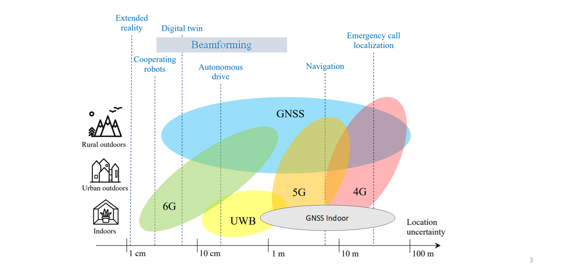
Figure 1: Main positioning technologies with their accuracy and usual applications.
In a nutshell, positioning consists of determining the current coordinates of a mobile and or fixed end-terminal (UE).
Satellite navigation solution (GNSS) generally works out a user equipment’s (UE) position by estimating the intersections between received signals (include satellite position and transmission time) from several satellites. This is a mobile based system enabling the UE to calculate its position.
In a wireless radio-based network, terminal position is calculated by a network server. In general, mobile location estimation is possible using Received Signal Strength (RSS), Time Difference of Arrival (TDoA), and Angle of Arrival (AoA) of radio signals, but all suffer from the issue of LoS. To apply these methods for positioning, multiple base stations (BS) with a priory known location must be utilised and along with geometric algorithms which are used to work out a UE’s position.
LIDAR - Light Detection and Ranging, is a laser-based sensing technology which is used in autonomous vehicles and robotics applications. The LIDAR emits laser pulses which echoes bounce off the object and return. These echoes’ time of arrival is then analysed to create a map of the surrounding objects. For mobile configurations, LIDARs are placed on moving entities such as cars.

Optical Wireless Positioning: A brief State-of-the-Art

Overview of the state-of-the-art
Given the criticality of positioning for current and future communication networks, many techniques have been proposed, including in the optical domain, as suggested by the numerous surveys on the subject published in recent years [ZHU18, TRA22, ZHU24]. Sometimes inspired from the radio frequency (RF) field [TRE23, YAN24], these optical wireless positioning (OWP) techniques can first be classified depending on whether they use cameras or photodiodes (PD) as optical receiver. In the first case, high spatial diversity and accuracy can be achieved thanks to advanced image processing and computer vision techniques, but cameras are not adapted to establish at the same time high data rate communication links.
In the OPTI-6G project, we focus therefore on PD-based OWP so that data transmission can be enabled in parallel, in an integrated sensing and communication (ISAC) approach. PD-based OWP techniques can then be classified according to their core principles, into four main categories:
- Proximity methods, where the UE’s position is estimated to be that of the closest AP, and which are therefore very easy to implement but provide very low accuracy (roughly equal to the AP density).
- Methods based on the measurement of the time-of-arrival (ToA) of signals coming from one or several APs (and its derivative, i.e. the time difference of arrival (TDoA), the phase of arrival (PoA) and the phase difference of arrival (PDoA) methods),
- Methods based on the measurement of the angle-of-arrival (AoA) of signals coming from one or several APs,
- Methods based on the measurement of the received signal strength (RSS) of signals coming from one or several APs.
Except for proximity, which will not be considered here because of its low accuracy, each of these methods, whose operating principles will be detailed in the following sub-sections, has its own advantages and disadvantages, so that their combination can be advantageous for obtaining an accurate fused position estimate of the UE. In addition, they can all be combined with data modulation techniques, so that OWC-based ISAC systems are completely feasible, as shown by some early work [LIN17, YAN18, KOU21, CHE22, JIN22, LIU23, YAN23, SHI24]. Table 1 lists some experimental OWP works representative of each main category, including works on OWC-based ISAC, along with their primary features.
While it can be seen that cm-level accuracy is the norm, it can also be observed that most experimental works published so far perform 2D positioning only, i.e. assume the height of the UE is known, and operate over rather small areas, which may be restrictive.
In addition, we can note that in almost all cases, it is necessary to use several transmitters [LIN17, YAN18, KOU21, APA22, CHE22, LIU23, YAN23, SHI24], several receivers [HON20, APA22, JIN22, SHI24] and even complementary sensors such as camera [HUA23], magnetic sensor [XIE16] or inertial sensors [LI17], which may induce space constraints, particularly if several receivers are necessary in a UE to be used in embedded IoT systems for example. In addition, these methods usually require knowledge of the transmitted power and are sensitive to the orientation of the receiver.

Reference | Year | 2D/3D | ISAC | Modulation | Positioning technique | Number of sources/PDs | Specificity | Data rate  (pre-FEC) | Positioning accuracy (type) | Testbed size
[LIN17] | 2017 | 2D | Yes | OFDMA | RSS | 3 LED / 1 PD | NA | 1.7 Mbaud | 1.68 cm (mean) | 20 x 20 cm²
[YAN18] | 2018 | 2D | Yes | FBMC | PDOA | 3 LED / 1 PD | NA | ND | 6.08 (mean) | 1.2 x 1.2 m²
[HON20] | 2020 | 2D | No | NA | AOA + RSS | 1 LED / 4 SC | Quadrant solar cell | NA | 3,09 cm (mean) | 40 x 40 cm²
[KOU21] | 2021 | 3D | Yes | OFDMA | TDOA | 3 LED / 1 PD | ITU-T G.9991-compliant | ND | < 10 cm (ND) | 1 x 1 x 2 m³
[APA22] | 2022 | 2D | No | NA | AOA + RSS | 4 LED / 4 PD | Quadrant PD with aperture | NA | 16,65 (95%) | 3 x 3 m²
[CHE22] | 2022 | 2D | Yes | CDMA | RSS | 4 LED / 1 PD | NA | 1-3 Mbps | 1.5 cm (mean) | 60 x 60 cm²
[JIN22] | 2022 | 2D | Yes | OOK | RSS | 1 LED / 5 PD | AFT based demodulation | 0.12 Mbps | 3.43 (mean) | 1 x 1 m²
[LIU23] | 2023 | 2D | Yes | DDM | RSS | 4 LED / 1 PD | NA | ND | 2 cm (96%) | 60 x 60 cm²
[YAN23] | 2023 | 3D | Yes | OFDMA | PDOA | 4 LED / 1 PD | Rotatable PD | 22.3 Mbps | 8 cm (80%) | 2 x 2 x 1.8 m³
[WAN24] | 2024 | 2D | No | NA | RSS | 1 LED / 1 PD | Rotatable PD | NA | 0,92 cm (mean) | 50 x 50 cm²
[SHI24] | 2024 | 2D | Yes | m-CAP | RSS | 4 LED / 3 PD | NA | 12 Mbps | 5.9 cm (90%) | 1.2 x 1.2 m²
Table 1: Overview of the state-of-the-art on experimental OWP and OWC-based ISAC (CDMA: Code division multiple access, DDM: Difference in depth of modulation, FBMC: Filter bank multi-carrier, ND: Non-defined, SC: Solar cell).
These different limitations and constraints will be better explained in the light of the operating principles of each technique, which are now going to be detailed. This will eventually allow us to position the ambition of the OPTI-6G project in Section 2.3.

Generic modeling of an OWP system
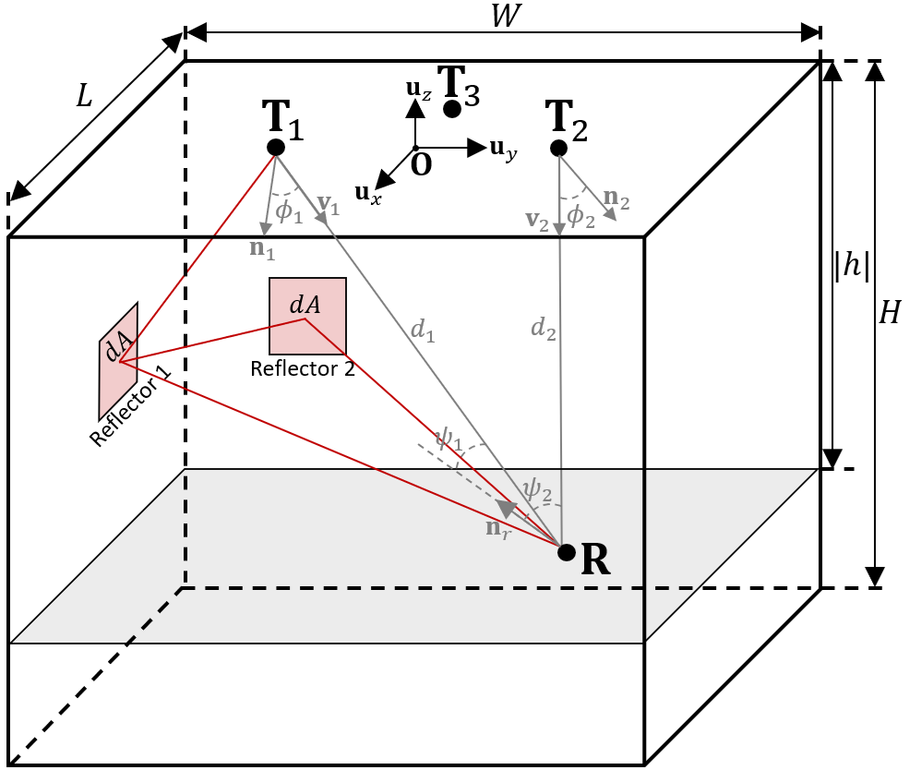
Figure 2: Geometrical modelling of a generic OWP system.
To better explain the operating principles of each OWC technique, we will consider in the following the basic use case of an indoor OWP system shown in Figure 2.
On the infrastructure side, three APs noted $T_{1}$, $T_{2}$ and $T_{3}$ (or $T_{i}$ when referring to any of these without loss of generality) are installed on the ceiling of a room of dimensions $L×W×H$. A main frame $F=\left(O, B\right)$ is associated to this environment, where $B=\{u_{x},u_{y},u_{z}\}$ is an orthonormal basis of $R^{3}$ and the origin $O$ has coordinates $O={\left[0,0,0\right]}^{T}$. Therefore, each AP $T_{i}$ has coordinates $T_{i}={\left[x_{i}, y_{i}, z_{i}\right]}^{T}$. In addition, each AP is equipped with at least one optical source, which orientation is defined by its support vector $n_{i}$.
On the user side, a UE noted $R$ may move anywhere in the room, and has therefore unknown coordinates $R={\left[x,y,z\right]}^{T}$, which means it is located at an absolute distance $d_{i}$ from the $i$-th AP, given by:
$$d_{i}=\left\|R-T_{i}\right\|=\sqrt{{(x-x_{i})}^{2}+{(y-y_{i})}^{2}+{(z-z_{i})}^{2}},$$ | (2.1)
Note that in case of 2D positioning only, its $u_{z}$-coordinate is known and assumed equal to $h$. Note also that this UE may have a varying orientation, which direction is defined by the support vector $n_{r}$.
In such an environment, the main role of any OWP system is to estimate the $x$, $y$ and $z$ coordinates of the UE by exploiting one or several physical parameters of signals sent by the APs and received by the UE, or conversely. In practice, such signals will propagate from one end to the other via a direct line-of-sight (LoS) path, of absolute distance $d_{i}$, but also via multiple indirect non-LOS (NLOS) paths of varying distances coming from reflections on the environment (see red paths in Figure 2). The resulting Channel Impulse Response (CIR) can thus be expressed as:
$$h_{i}\left(t\right)=\sum_{j=0}^{+∞}{h_{i,j}(t-τ_{i,j})},$$ | (2.2)
where $h_{i,0}(t-τ_{i,0})$ is the LoS CIR, of delay $τ_{i,0}=\frac{d_{i}}{c}$, with $c$ the light celerity, and ${\left\{h_{i,j}\left(t-τ_{i,j}\right)\right\}}_{j>1}$ are the NLoS CIRs of delays $τ_{i,j}$. As we will see in Section 2.2.3, these delays are critical when using TOA-based positioning methods.
When considering the other types of methods, especially RSS and AoA, the propagation delays may be neglected as long as the transmitted signal bandwidth remains close to the channel coherence bandwidth, i.e. typically around a few tens MHz’s. However, the CIR gains cannot be ignored, as they will have a direct incidence on the optical power of the received signal, so their expression may be useful.
These expressions will themselves depend on the beam pattern of emission of the optical source used, and on the geometry of the link. Let us therefore assume that the APs, installed according to the configuration previously detailed and shown in Figure 2, are each equipped with an LED, which pattern of emission typically follows a generalized Lambertian law of order $m_{i}$. In such a case, the LoS channel gain from the $i$-th AP to the UE, noted $H_{LOS,i}$, will be:
$$H_{LOS, i}=\left\{\begin{aligned}\frac{A_{r}\left(m_{i}+1\right)}{{2πd}_{i}^{2}}\cos^{m_{i}}{ϕ_{i}}\cos{ψ_{i}} if \left\{\begin{aligned}0≤ϕ_{i}≤\frac{π}{2} \\ 0≤ψ_{i}≤Ψ_{c}\end{aligned}\right. \\ 0 otherwise\end{aligned}\right. ,$$ | (2.3)
where $A_{r}$ is the sensitive area of the PD used at the UE level, $ϕ_{i}$ is the angle of emission (or angle of irradiance), $ψ_{i}$ is the angle of reception (or angle of incidence, which has to remain smaller than the PD’s field-of-view $Ψ_{c}$), and $m_{i}$ is the Lambertian order of the LED, defined as $m_{i}=-\ln\left(2\right)/\ln{(\cos{ϕ_{1/2}})}$, with $ϕ_{1/2}$ the semi-angle at half-power of the LED.
On its side, the NLoS gain, noted $H_{NLOS,i}$, can be evaluated using different methods, from the efficient but basic frequency-domain technique proposed by Schulze [SCH16] to advanced ray tracing techniques, that are more complex but also much more adapted to complex environments. In the end, assuming all APs transmit signals of identical average optical power $P_{t}$, the optical power $P_{i}$ of the signal received by the UE from the $i$-th AP will be given by:
Pi=HLoS, i+HNLoS, iPt. | (2.4)

T(D)oA and P(D)oA-based techniques
As highlighted in Section 2.2.1, a first common method to find the position of the UE is to measure the ToA, TDoA, PoA or PDoA of one or several signals sent by one or several APs [YAN18, KOU21, YAN23]. The general idea behind TOA-like methods remains the same: if the LOS propagation time of each signal from its original AP to the UE can be evaluated, it is then easy to deduce the corresponding AP-to-UE distance, given that its propagation speed is that of light. By trilateration, it is eventually possible to find the coordinates of the UE.
For example, let us assume, as represented in Figure 2, that three different APs, $T_{1}$, $T_{2}$ and $T_{3}$, transmit each a signal to the UE. If the UE can estimate exactly the three LOS propagation delays $τ_{i,0}$, then according to (2.1), we can observe that:
$$τ_{i,0}=\frac{d_{i}}{c}=\frac{\sqrt{{\left(x-x_{i}\right)}^{2}+{\left(y-y_{i}\right)}^{2}+{\left(z-z_{i}\right)}^{2}}}{c}.$$ | (2.5)
Assuming now the height of the UE is known (i.e. $z=h$), then (2.5) can be reformulated as:
$${\left(x-x_{i}\right)}^{2}+{\left(y-y_{i}\right)}^{2}=c^{2}τ_{i}^{2}-{\left(h-z_{i}\right)}^{2},$$ | (2.6)
i.e. as a polynomial equation with two unknowns $x$ and $y$. Using three such equations, or in other words signals coming from three different APs, it is eventually possible to find unique $x$ and $y$ coordinates. In case the $z$ coordinate of the UE is not known (3D positioning case), then an additional AP will be necessary, i.e. four APs in total.
Advantages: ToA-like methods have several advantages, starting with the fact that they do not need any knowledge of the channel model to operate, as they only rely on time (or phase) measurements. In addition, if the propagation times are measured with sufficient accuracy, then the positioning accuracy can be extremely good.
Drawbacks: However, note that as light travels around 1 cm in 33 picoseconds only, very short times must therefore be accurately measured, which can be very challenging. In general, these measurements are done by comparing a time stamp of emission and a time stamp of reception. This efficient method nevertheless requires that APs and UEs be perfectly synchronized, which can be very complex to achieve. By relying instead on the TDoA of signals from two APs, it is possible to alleviate the AP-UE synchronization constraint to a synchronization between APs only, so that hyperbolic methods can then be used to estimate the UE’s coordinates. Note however that, whatever the method employed, the ToA/TDoA measurement will anyway be disturbed by the NLoS paths, which will make the exact measurement of the reception time more complex. In addition, it is clear from the previous equations that several APs are needed to achieve 2D or 3D positioning.

RSS and AoA-based techniques

Overview
RSS is an essential metric for localization in various communication systems. RSS-based localization is widely used in systems like Wi-Fi, cellular networks, and OWC [XIE16, LI17, CHE22, JIN23, LIU23, SHI24, WAN24]. A critical factor in assessing the performance and accuracy of these systems is the RSS parameter, which measures the power of the signal received by an antenna or photodetector.
In OWC, the RSS is determined by the intensity of the light reaching the photodetector, which is affected by the transmit optical power as well as by the distance from the light source, obstacles, and other environmental variables. RSS-based localization estimates the position of a user or object by analyzing the signal power received from multiple light sources. Path-loss models allow the system to estimate distances based on RSS measurements and compare these to the known positions of transmitters, as detailed in the next sub-section.
In OWC systems, RSS measurements have unique characteristics due to the nature of light propagation. Unlike RF-based systems such as Wi-Fi or cellular networks, light signals do not pass through walls and follow more predictable propagation patterns. This characteristic can improve localization accuracy, as LoS is usually required for OWC systems. There are, however, both advantages and disadvantages to using RSS for localization in OWC systems.
The advantages of RSS-based OWP are:
- Cost and simplicity: Localisation using RSS is considered cost-effective as no additional hardware is required. The existing OWC transceivers (LEDs and photodiodes) can be used for this purpose. The system only needs to measure the strength of the received signal, making it an affordable option for localization. Since measuring the received signal power is required, no complex algorithms nor additional hardware are required, the RSS localisation is relatively simple to implement, which can be easily integrated into OWC systems.
- Applications: RSS localization can support a wide range of applications, including indoor scenarios like factories, smart homes, hospitals, or offices. In OWC, the technique is suitable for environments where precise indoor localization is required. Due to its immunity to electromagnetic interference (RF systems), using OWC systems for communication and localisation including RSS localization is ideal for applications in environments sensitive to RF interference (e.g., hospitals, airplanes).
- High accuracy: The RSS localisation in OWC has the potential to achieve high accuracy when LOS links are available in the system. The signal strength in OWC follows predictable attenuation patterns when there is clear LoS between the transmitter and receiver. In some OWC systems, RSS localization can operate in NLoS conditions, meaning that even if the LoS links are blocked, reflected or scattered light can still provide enough signal strength for localization.
The disadvantages of RSS-based OWP are:
- Signal attenuation: RSS-based methods heavily depend on the accuracy of the signal strength measurement. In OWC, signal attenuation due to obstacles, reflections, or distance from the transmitter can degrade the localization accuracy [MAH24a]. Factors like shadowing or varying light intensity can introduce errors. OWC systems usually have a limited range compared to RF-based systems. This limits the effective localization coverage area, making it more suited to small, controlled environments like rooms or small office spaces.
- Environmental sensitivity: RSS localization in OWC is highly sensitive to environmental factors such as lighting conditions, reflections from walls or objects, and interference from ambient light sources (e.g., sunlight, fluorescent lights). These factors can introduce inaccuracies in the received signal strength. Furthermore, in environments where objects or people move frequently, the signal strength may fluctuate, causing inaccuracies in the localization process. This is especially relevant in OWC systems where LOS conditions can easily be interrupted by human activity. In indoor OWC systems, multipath reflections from walls, floors, and other surfaces can affect RSS measurements, leading to inaccurate distance estimation. This is particularly challenging in complex indoor environments with many reflective surfaces.
- Requires LoS for high accuracy: While RSS can work in NLoS conditions, the highest accuracy is typically achieved in LoS scenarios. In environments where the LoS between the OWC transmitter and receiver is obstructed, the localization accuracy drops significantly.
- Calibration requirements: Accurate RSS localization in OWC often requires careful calibration of the system, including determining the relationship between the received signal strength and distance under different conditions. This calibration can be time-consuming and must be periodically updated as environmental factors change.
On their side, methods based purely on AoA measurement cannot be implemented directly with PD receivers, but rather require the use of camera or inertial sensors [HUA23, LI17]. If only PD receivers are used, the angle measurement amounts to an RSS measurement which is then processed to give angles. Therefore, PD-based AoA positioning is equivalent to RSS-based AoA positioning (or ‘AoA+RSS’ in Table 1 [HON20, APA22]). As this type of method is not so common, we will limit ourselves in what follows to describing the main operating principles of RSS methods only.

Working principles
From a general point of view, the core idea of RSS-based positioning is to estimate, from the RSS of signals coming from different APs (e.g. $T_{1}$, $T_{2}$ and $T_{3}$ in Figure 2), the absolute distances $d_{i}$ between these APs and the UE using a known path loss model. Trilateration is then used to determine the unique point in space located at these estimated absolute distances from the APs, as represented in 2D in Figure 3.
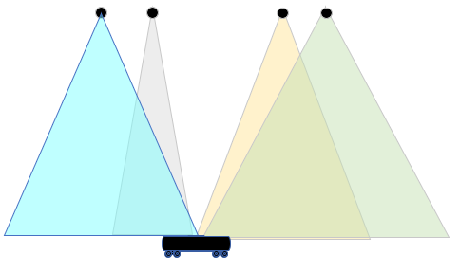 | 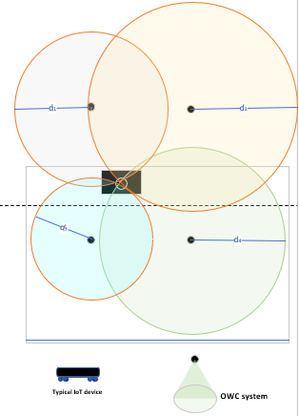
Figure 3: RSS Localization in OWC System.
From a mathematical point of view, and with reference to Figure 2, we can easily express these working principles in the basic 2D positioning case. Let us assume that the APs are all pointing to the floor (i.e. $n_{1}=n_{2}=n_{3}=[0,0,-1]$) and that the UE, of height $h$, is pointing to the ceiling (i.e. $n_{r}=[0,0,1]$). Then, we can observe that:
$${\cos{ϕ}}_{i}={\cos{ψ}}_{i}=\frac{h}{d_{i}}.$$ | (2.7)
According to the LOS path-loss model (2.3), and neglecting the NLOS paths in (2.4), this means that the optical power $P_{i}$ received from the $i$-th AP will be:
$$P_{i}=P_{t}⋅\frac{\left(m_{i}+1\right)A_{r}}{2πd_{i}^{m_{i}+3}},$$ | (2.8)
which, combined with (2.1), gives:
$${\left(x-x_{i}\right)}^{2}+{\left(y-y_{i}\right)}^{2}={\left[\frac{P_{t}}{P_{i}}⋅\frac{\left(m_{i}+1\right)A_{r}}{2π}\right]}^{\frac{1}{m_{i}+3}}-{(h-z_{i})}^{2}.$$ | (2.9)
Assuming the transmitted power $P_{t}$, the Lambertian order $m_{i}$ of the APs, the coordinates $x_{i}$, $y_{i}$ and $z_{i}$ of the APs, and the height $h$ of the UE are known, then by simple measurement of the RSS, we can deduce $P_{i}$ and thus obtain multiple equations with two unknowns $x$ and $y$. In practice, three such equations must be used to find unique solutions for $x$ and $y$, which can be done using three different APs [SHI24, MAH24b]. In other words, 2D RSS positioning requires at least three separate optical sources to operate properly [ZHU24]. In addition, the transmitted optical power must be known, and the orientation of the receiver has a strong influence on the positioning estimate.

Positioning of OPTI-6G Compared to the State-of-the-Art
The OPTI-6G project aims to implement three distinct OWP methods, each with their respective advantages and disadvantages, and then fuse them to produce an even more accurate and robust aggregate estimate of UE location.
These three OWP methods are as follows:
- A method based on the measurement of TDoA from several APs. As further detailed in Section 3. The main novelty in this research compared to the state of the art lies in the ability of this patented method to measure the TDoA (time difference of Arrival) with a resolution and accuracy of tens of picoseconds which enables a centimeter level UE location measurement in real time which represents two orders of magnitude improvement compared to the current art which is currently a few meters.
- A method based on the measurement of RSS from several APs. As further detailed in Section 4, [detail novelties compared to the state of the art and main advantages - @UBRUNEL].
- A hybrid RSS and AoA method based on modulating the orientation of one or several optical sources using beam-steering techniques. As further detailed in Section 5, this method enables 2D positioning with only a single optical source (i.e. a single AP) and a single PD at the UE level, whereas 3D positioning can be achieved with only two APs. In addition, this method is not affected by the optical power transmitted and the orientation of the UE.

UE Localization Sensing based on Time of Arrival measurements

Theoretical basis
Project Positioning method principles – The service is based on highly accurate Differential Time of Arrival (DToA) measurements followed by hyperbolical trilateration process, as shown in Figure 4.

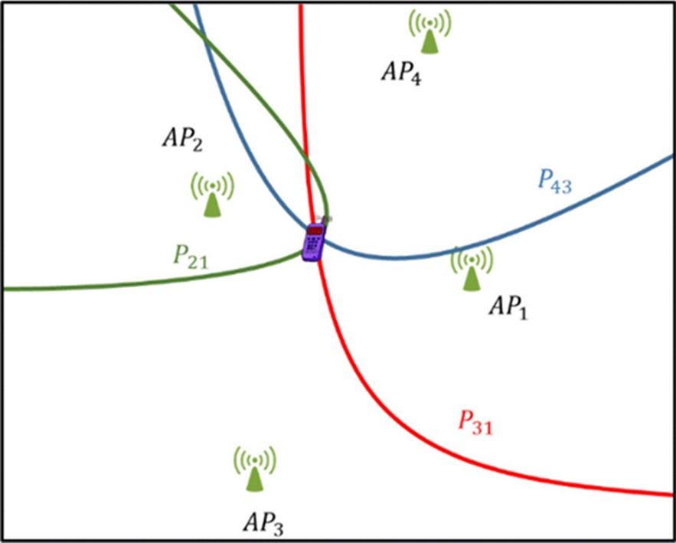
Figure 4: Hyperbola pattern crossing at the target UE position
Whereas The positioning method principles for ToA are presented in the following figure.
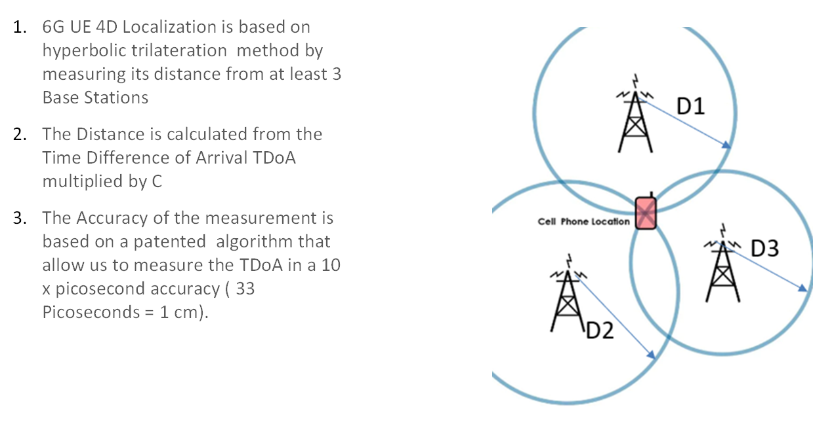
Figure 5: UE location measurement based on TDoA trilateration
The system is capable of measuring time intervals with a resolution of 0.3 picoseconds, which corresponds to less than a centimeter ranging. However, RF channel noise and multipath reflections limit the performance to several centimeters, as dependent on the scenario and antennae structure.
4G, 5G and B5G mobile networks air interface is based on OFDM/OFDMA modulation. In general, Time of Arrival (ToA) for User Equipment (UE) can be extracted using air interface embedded Reference Signals (RS), such as:
- Demodulation Reference Signals (DMRS)
- Positioning Reference Signals (PRS)
- Sounding Reference Signals (SRS)
Alternatively, ToA can be derived from the data itself by remodulating the transmitted signal and comparing it to the received signal, creating a pilot-like structure.
To enhance the measurements accuracy a differential DToA technique is applied to cope with the phase jitter induced by each base-station. A distributed antenna with front end processing can further enhance the measurements accuracy.
RunEL has a patent for this method.
However, in Non-Line-of-Sight (NLoS) environments, closely spaced multipaths can degrade ToA estimation accuracy, leading to reduced resolution and measurements accuracy.
To cope with the RF channel multipath advanced techniques boosted by AI processing are currently developed by RunEL R&D experts.

Localization System Architecture
The following figure sets the general block diagram including the means for accurate positioning to measure the position of a mobile end terminal.
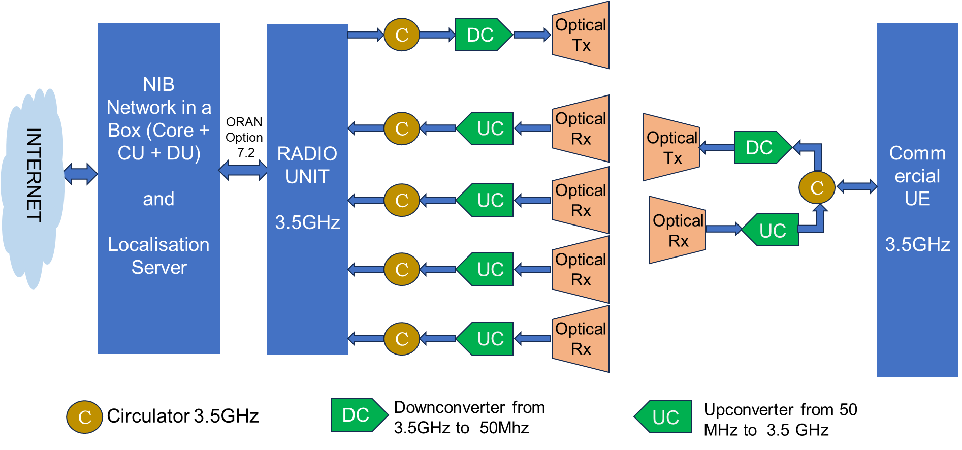
Figure 6: System General Block Diagram including UE Position Measurement
Based on the above configuration a single site location measurement system will be planned. The system includes a single site connected to a 3-branch distributed antenna.
Wireless to optical converters will be at the front of the RF chain at each branch.
At each port of the branches, front end processors will decode a received replica of the UE UL signal and will digitize and process this signal. The signal will be transformed by FFT (Fast Fourier Transform) to frequency domain.
The magnitude of the OFDMA signal subcarriers interphase difference change (which is related to propagation delay) between the replicas OFDMA will be processed. This is carried out for each pair of digitized signal replicas which are received by the antenna elements frontend receivers. (the phase differences are translated to differential time of arrival relative to the reference sampling time of the receiver).
The fact that all replicas are linked to the same RU with a common reference sampling time for all antenna elements frontend makes the measurement of the DToA simple, with no need for complex calibration process and provides a very accurate measurement.
A diagram of the signal’s connectivity for the DToA processing is depicted below.
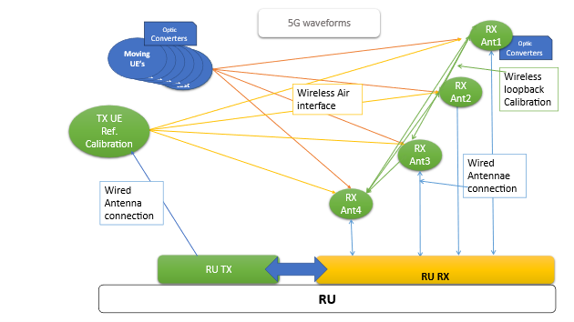
Figure 7: Accurate DToA processing
The timing measurements are transferred to the positioning server which carries out a hyperbolic trilateration process using each branch processor DToA measurements.
A known location fixed UE is used to calibrate the processing.
The positioning architecture is depicted in the following drawing.
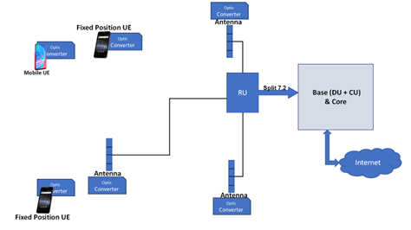
Figure 8: Distributed Antennae Positioning Architecture Diagram
Such a solution, which is based on the received signal sub-carriers phase change resolves the time difference measurement beyond the sampling time resolution. The processing is carried out after the digitization and FFT processing yielding extra resolution and measurements accuracy, up to 2-3 magnitudes of order compared with regular DToA measurements.
By using this architecture, the phase jitter impact and synchronization errors will be almost avoided yielding a very accurate measurement of the DToA for each antenna branch.
Since the OWC antenna is not able to be beam-steered, then the UE Tx OWC Antenna, Ref Tx OWC Antenna and gNB Rx OWC Antenna may be required to be co-linear with each other, as shown in Figure 9 to receive a sufficiently strong signal above the noise floor to signal process the OFDM for obtaining ToA. Note that X1 and Y1 are the lengths of the Optical Fibre cable, which are proportional to the propagation times, needed to calibrate the overall propagation time of transmitted signal.
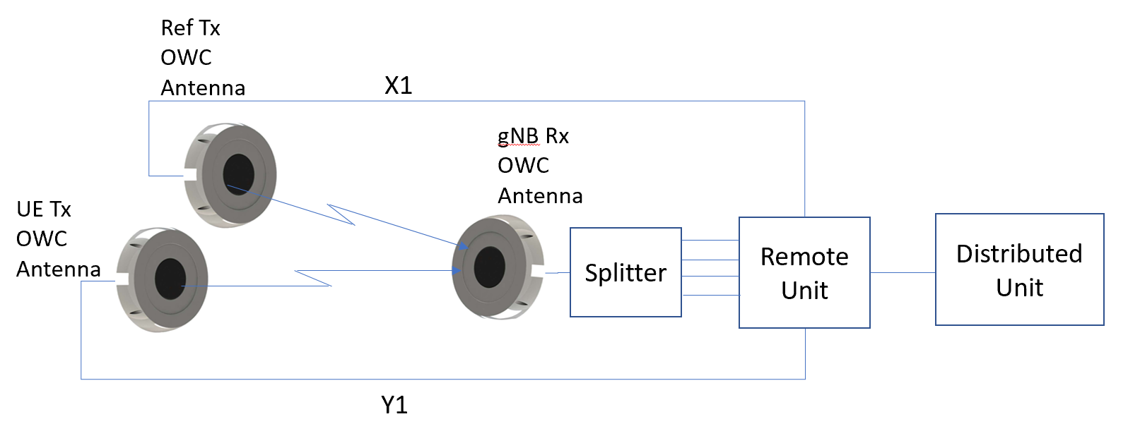
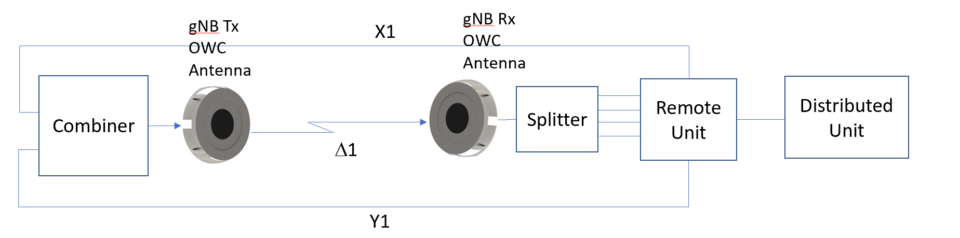
Figure 9: OWC- Positioning Architecture Diagram

Localization System Design
The TDoA based UE localization system consist of a standard commercial 5G private end to end network (See Figure 6 above) that includes a Server with the 5G Private Core, the Control Unit (CU) and the Distributed Unit (DU) connected via the ORAN interface (option 7.2) to a Radio Unit with four TX/RX channels that have been modified to work in the optical domain (1050 nanometer) instead of the sub six Microwave Band (3.3 to 3.8GHz).
The Private 5G Network is connected to a User Equipment (UE) that also was modified to communicate with the 5G Network in the optical band (1050 nanometer) as explained in deliverable D3.1
The main design challenges in regard to the UE location measurement research is in the in the O-RAN Interface between the RU and the DU due to the fact that the dedicated Time of Arrival (ToA) measurement module within the RU needs information from the DU on the allocation of some specific data stream coming from the UE on the uplink as described in the following paragraphs:
• Positioning detection in the RU, is based on distance measurements from UE transmit antenna to each RU receive antenna.
• Distance measurements are derived from knowledge of the channel state of each antenna.
• Accuracy of the location estimation depends on the location of the RU receive antennas.
• Therefore, channel state must be calculated for each UE whose location is required.
• The RU ToA measurement processor needs to have the exact allocations to the user and from the user in real time.
• The RU calculates the ToA based on the channel state and the following parameters in the uplink (UL): UE RNTI (16 bit); Type (4 bit); DMRS, SRS, etc.; Type parameters (about 6 bit); Symbol (4 bit); First RB (9 bit); Number of RB (9 bit); Number of OFDM symbols (pilots + data).
The parameters above are known at the scheduler in the DU Media Access Controller (MAC) layer and are needed in the RU at the same timing as the uplink C-plane.

Target KPIs
The proposed TDoA based UE location measurement technique is eventually expected to meet the following KPIs:
- Localization accuracy:
  - Target value: < 5cm.
  - KPI definition: $ε_{90\%}$ the root mean square (RMS) error threshold under which 90% of the RMS errors on all the 2D/3D test points considered are.
- Coverage:
  - Target value: 2m x 2m x 2m.
  - KPI definition: The coverage is defined as the volume in which the UE can be located with accuracy as defined above.
- Extra-latency:
  - Target value: < 10 msec.
  - KPI definition: Extra-latency is defined as the time needed to orientate the APs in all the necessary directions and then estimate the UE’s localization, including with the ML layers. However, this latency does not include the transmission latency from the UE to the AP, for further processing by the localization server, which is why it can be seen as the extra-latency added by the proposed OWP technique compared to the case it is not used.
- ISAC-compatibility:
  - Target value: Yes.
  - KPI definition: The proposed TDoA based UE location measurement technique should not degrade the communication performance of the OPTI-6G system (see D3.1 for more details about this communication function).

Potential Risks
The main potential risks in the DToA based UE localization research lies in the following areas:
- Integration with third party ORAN Interface between the DU and RU to extract the real time parameters at the RU described in paragraph 3.3 above. To mitigate this risk, RunEL is holding weekly sessions with the DU ORAN interface protocol stack to complete the development with this specific interface.
- The multipath interference in indoor environment substantially reduces the accuracy of the UE location measurement. Opti 6G believes that the use of OWC communication instead of the sub 6GHz 5G spectrum will substantially reduce the multipath due to the natural higher attenuation of the optical signals compared to the microwave signals at the 3.5GHz band.

Tests Principles and Test Plans
The detailed test plans that will be put in place to validate the proposed ToA-based OWP technique will be detailed in Deliverable D4.3, but a general outline of these plans are outlined in Chapter 3 of deliverable D6.4 of the 6G Brains project [COS23] where a similar test was performed at 3.5GHz spectrum while in the Opti 6G case it will be done in the optical domain.
These validation tests broadly consist in validating the accuracy, latency and positioning coverage of the proposed method. To this end:
- The UE is successively positioned at different locations, the coordinates of which are known (using external sensors, such as a laser rangefinder, and/or from the reference of the double axis plotter, which is programmable).
- At each location, a position estimation process is then performed, to obtain an estimate of the UE coordinates.
- This estimate is compared with the actual coordinates to obtain an RMS error.
- At the same time, a timer is triggered to determine the latency of the positioning measurement.
- The empirical CDF of all these RMS errors is then evaluated, to determine the accuracy metric $ε_{90\%}$, defined in Section 3.4. An average latency can also be defined from the latency measurements made for each location.

UE Localization Sensing based RSS measurements

Theoretical basis

Fingerprinting
One of the prominent methods for localization in OWC systems is RSS-based fingerprinting, which uses the RSS at various points in an environment to create a “fingerprint” of the location [HE16].
Fingerprinting is a two-stage localization technique used to estimate a device's position based on previously collected signal data. The technique relies on building a database of signal characteristics (RSS in this case) at various known locations during an offline phase. In the online phase, the device’s RSS measurements are matched against the database to estimate its location. RSS fingerprinting is widely used in indoor environments where multipath fading and NLoS conditions make other localization techniques, such as trilateration, less effective.
In OWC systems, fingerprinting typically involves collecting RSS data from light sources (e.g., LEDs) at different positions in the area of interest. Given that light propagation is typically LoS in OWC systems, RSS measurements tend to be more stable than in RF systems, where multipath fading and interference are more pronounced. The RSS fingerprinting process in OWC systems involves two main phases: the offline phase (training) and the online phase (testing or real-time localization) as shown in Figure 4.1.
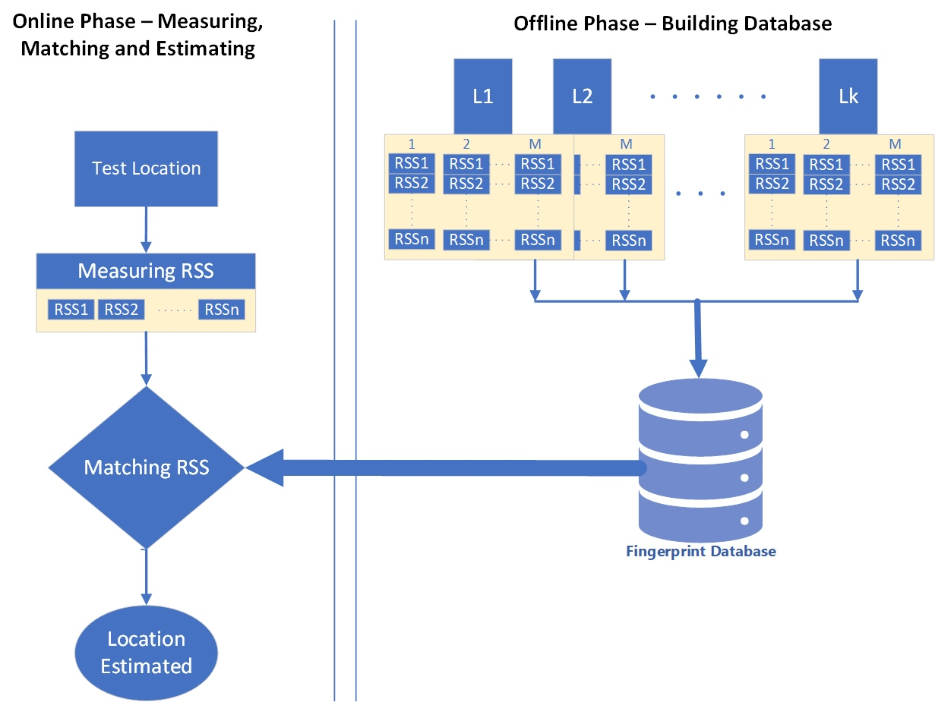
Figure 10: Fingerprint Algorithm
Offline Phase: Building the Fingerprint Database
In the offline phase, the area of interest is divided into a grid of known reference points ($k$ locations as shown in Figure 10). At each reference point, RSS values are recorded from multiple light sources ($n$ anchors as shown in Figure 10). These values are stored in a fingerprint database, where each entry contains the RSS measurements and the corresponding reference point location.
The fingerprint at a location $L$ can be represented as:
$$FP\left(L\right)=\left[{RSS}_{1}, {RSS}_{2}, {RSS}_{3}, … {,RSS}_{n}\right],$$ | (4.1)
where ${RSS}_{i}$​ is the received signal strength from the $i$-th light source (or LED) at location $L$ and $n$ is the number of light sources. From (2.4), and considering noise, we can express ${RSS}_{i}$ as:
$${RSS}_{i}=RSS\left(d_{i}\right)=P_{t}(H_{LOS,i}\left(d_{i}\right)+(H_{NLOS,i}\left(d_{i}\right))+N_{0},$$ | (4.2)
where $P_{t}$ represents the transmitted optical power by individual LED, $H_{LOS,i}\left(d_{i}\right)+$ $H_{NLOS,i}(d_{i})$ is the channel gain, with $H_{LOS,i}(d_{i})$ given in (2.3), and $N_{0}$ is the noise power.

The accuracy of the fingerprinting process depends on the number of reference points and the density of the grid.
Online Phase: Matching and Localization
In the online phase, a device measures the RSS values from multiple light sources at an unknown location. These measured values are compared to the fingerprint database to find the best match. The location corresponding to the closest matching fingerprint is estimated to be the location of the device. The matching can be performed using various techniques, such as Euclidean Distance and K-Nearest Neighbors [ZHA22]. For instance, the location can be obtained with the smallest Euclidean distance between the measured RSS and the stored fingerprint:
$$E\left(L\right)=({RSS}_{1}-\overline{{RSS}_{1}})^{2}+ ({RSS}_{2}-\overline{{RSS}_{2}})^{2}+ ({RSS}_{3}-\overline{{RSS}_{3}})^{2}+…+ ({RSS}_{n}-\overline{{RSS}_{n}})^{2},$$ | (4.3)
where $\overline{{RSS}_{i}}$​ is the measured RSS from the $i$-th light source in online phase.
Due to the line-of-sight (LOS) nature of OWC, RSS measurements are typically more stable and less affected by multipath fading and interference than in RF systems. This leads to more accurate fingerprints and, consequently, more precise localization results. However, the fingerprinting in OWC systems also has some issues related to environmental factors, time and complexity in the offline phase and different devices sensitivities. For instance, objects moving between the transmitter and the receiver can block or attenuate the signal, leading to localization errors.
In large environments, creating an RSS fingerprint database requires extensive time and resources labour. Moreover, environmental changes, such as moving furniture or new obstacles can significantly invalidate the data gathered in the offline phase. Furthermore, the devices may have different sensitivities which results in variations in RSS measurements and inaccurate localisation.

Artificial Neural Networks (ANN) for Localization
Artificial Neural Networks (ANNs) are a type of machine learning model inspired by the human brain’s structure and function. ANNs consist of interconnected nodes, known as neurons, organized into layers: input layers, hidden layers, and output layers. They are particularly effective in identifying patterns in complex, non-linear data, making them suitable for tasks such as image recognition, speech processing, and, in this case, RSS-based localization.
RSS-based localization involves non-linear relationships between the RSS values from multiple LEDs and the physical location of the receiver. ANN models are well-suited to model these non-linear relationships because they can “learn” from data to map RSS measurements to positions. The key benefits of using ANN for localization include:
- Learning from data: ANNs can learn the complex relationships between RSS values and physical positions by training on a dataset of RSS measurements.
- Handling non-linearity: ANNs are capable of capturing non-linear dependencies, which can improve accuracy in environments were multipath fading or shadowing affect RSS measurements.
- Robustness: ANN-based models can be trained to handle noisy or variable RSS data, providing more reliable localization compared to traditional methods.
The process of RSS-based localization using ANN can be divided into two main stages: the training stage and the localization (testing) stage.
Training Stage
In the training stage, an ANN model is trained using a dataset of RSS measurements collected at known reference points in the environment. The process is as follows:
- Data Collection: The environment is divided into a grid of known reference points. At each reference point, RSS values are measured from multiple LED transmitters.
- Feature Extraction: The RSS values from all the LEDs at each reference point are used as input features for the ANN model. The corresponding location coordinates (e.g., $x$, $y$) of the reference points are the output labels.
- Training the ANN: The RSS data and location labels are used to train the ANN model. The model learns to map the RSS values to the corresponding location using backpropagation and optimization techniques.
The training process adjusts the weights of the ANN to minimize the error between the predicted location and the actual reference point.
Localization Stage
In the localization stage, the trained ANN model is used to estimate the position of the device based on real-time RSS measurements.
- RSS Measurement: The device measures the RSS values from the available LEDs in real-time.
- ANN Prediction: The measured RSS values are fed into the trained ANN model. The ANN processes the input and outputs the estimated location of the device (e.g., its $x$, $y$ coordinates).
- Localization Output: The predicted location is used to provide the final position estimate of the device within the environment.
ANN Architectures for RSS-Based Localization:
- Feedforward Neural Networks (FNN)
The most basic type of ANN used for RSS-based localization is the Feedforward Neural Network (FNN). FNNs consist of an input layer (RSS values), one or more hidden layers, and an output layer (predicted location). Each neuron in a layer is fully connected to the neurons in the next layer. The number of hidden layers and the number of neurons in each hidden layer can be adjusted based on the complexity of the environment and the amount of training data. More complex environments with significant multipath effects may require deeper networks to capture the non-linear relationships between RSS and location accurately.
- Convolutional Neural Networks (CNN)
Convolutional Neural Networks (CNNs), typically used for image recognition, can also be adapted for localization by treating the RSS measurements as a spatial grid. CNNs can capture spatial patterns in the RSS values and can be particularly effective when there is spatial correlation between RSS measurements from different transmitters.
- Recurrent Neural Networks (RNN)
For dynamic environments where the device moves, Recurrent Neural Networks (RNNs) can be used to take advantage of temporal dependencies between successive RSS measurements. RNNs can maintain a memory of past measurements, which is useful for continuous localization tasks where the device’s movement can be tracked over time.
Advantages of ANN-Based Localization
- High Accuracy: ANN models can significantly improve the localization accuracy by learning the complex relationships between RSS and location, especially in environments with non-line-of-sight conditions.
- Robustness to Noise: ANN models are robust to noise in the RSS data, allowing for more reliable position estimates in the presence of environmental interference.
- Adaptability: ANNs can be retrained with new data when the environment changes, allowing them to adapt to dynamic environments with minimal manual intervention.
Challenges in Using ANN for Localization
- Data Collection: The training phase requires extensive data collection at known reference points, which can be time-consuming, particularly in large or complex environments.
- Computational Complexity: Training deep ANN models can be computationally intensive, and real-time localization using large networks may require significant processing power.
- Generalization: ANN models trained in one environment may not generalize well to other environments without retraining, limiting their applicability in different settings.

Localization System Architecture
The OWC system in Brunel lab consists of an Oledcom LiFiMAX which consists of several entities as shown in Figure 11. Each entity has a specific role as illustrated later in this report.
- The LiFiMAX® Access Point. A maximum of 6 Photonic Antennas can be connected per Access Point.
- The LiFiMAX® Photonic Antennas (83-degree opening angle) - which connect to the Access Point via a dedicated RJ45 cable.
- The USB-C LiFiMAX® Dongle (or EP - End Point) to connect user devices.
- The LiFiMAX® Controller software is hosted in the Access Point.
- Router. DHCP server to assign an IP address to the Access Point / controller.
- POE+ Switch. The power supply of the Access Point is done by POE+ Switch.
- Aluminum Frame.
- 3D plotter and/or UAV, Car
- User. PC or RPi
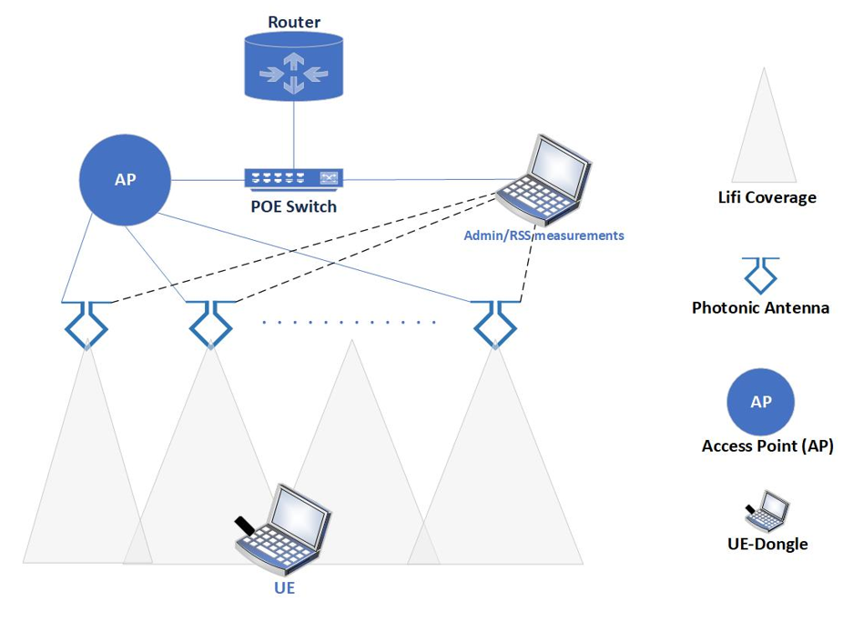
Figure 11: OWC System architecture in Brunel Lab.
The coverage area depends on the number of connected antennas. Each antenna projects a light field with a 940 nm wavelength, invisible to the naked eye, which interacts with receivers when an optical link is established. Figure 12 illustrates the operating distance and coverage area of the AP. Figure 13 displays the uplink and downlink data rates between the APs and receiver based on distance.
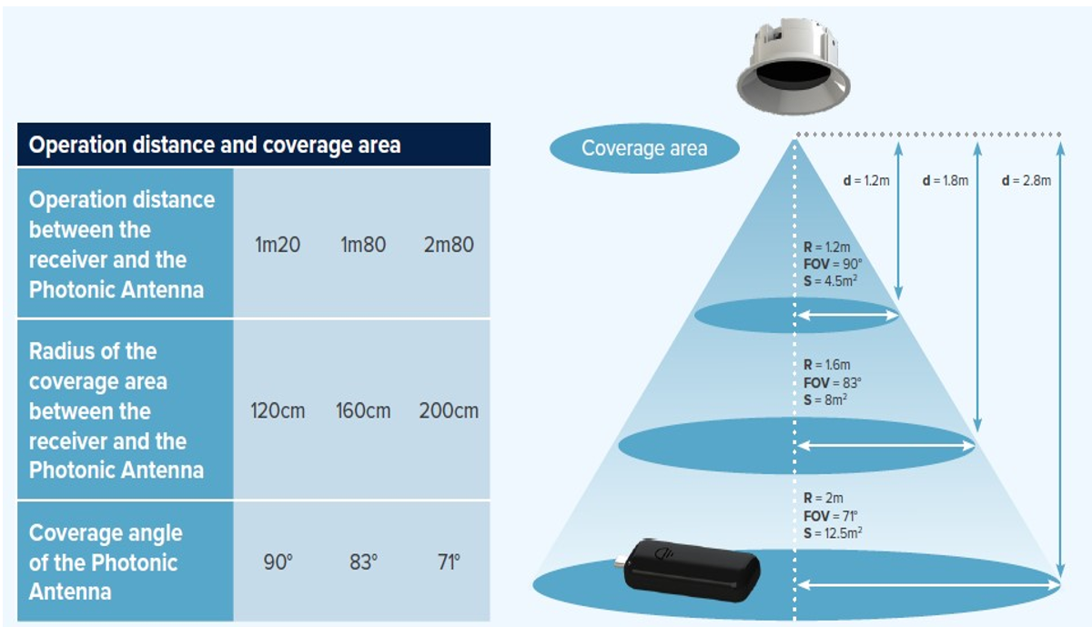
Figure 12: Operation distance and coverage area.

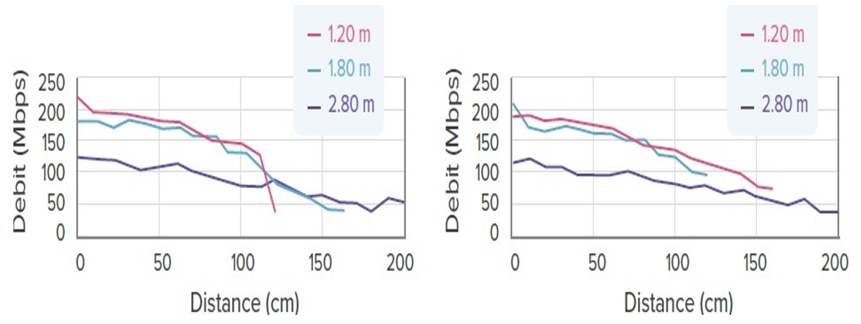
Figure 13: Uplink (left) and downlink (right) data rates.

Localization System Design
Figure 14 shows a first implementation of the RSS-based positioning system, which architecture was detailed in Figure 11. This demonstrator, initially developed to carry out first tests (see [SHI24]), is not the final OPTI-6G system but is composed of similar components and thus gives a first view of the intended final demonstrator.
As shown in Figure 14(a), a computer ① is used to first generate the signal to be sent by the APs with MATLAB (e.g. constant signal or data signal modulated with OFDM, etc.), and then transmit it to the USRP X300 ② via an Ethernet link controlled by the GNU Radio software. The USRP then transmits in loop this signal in its baseband analog form thanks to an Ettus BasicTX daughterboard. However, this analog signal may have a too low peak-to-peak amplitude to drive the AP’s optical antenna correctly and may therefore be amplified beforehand by a power amplifier ③, powered by an external power supply ④.
Then, as shown in Figure 14(b), this AP’s optical antenna ⑤, provided by OLED, is installed on the ceiling of a test area (here of dimensions 1.2 x 1.2 x 2.16 m³). At the other end of the link, a second optical antenna ⑥, this time serving as a UE, is mounted on a double rail ⑦ enabling it to be positioned precisely in an $u_{x}$-$u_{y}$ receiving plane. The entire test area may be protected from external light interference by black curtains ⑧.
The UE’s optical antenna, fed on the one hand by the external power supply ④ is on the other hand connected to the USRP X300 ②, which uses a Basic RX daughter board to convert the received analog signal into its digital equivalent. This digital signal is eventually recorded as a vector of samples in real time by the computer ① through GNU Radio. Once recorded, these samples are eventually post-processed with MATLAB to evaluate the communication and positioning performance of the proposed system, including ML techniques if required.
Note that, as four APs are normally required for the RSS positioning technique used to work properly, the measurement just described must be reproduced with the AP’s optical antenna positioned in a different location (this is eventually equivalent to using four different APs in a time division multiplexing approach).

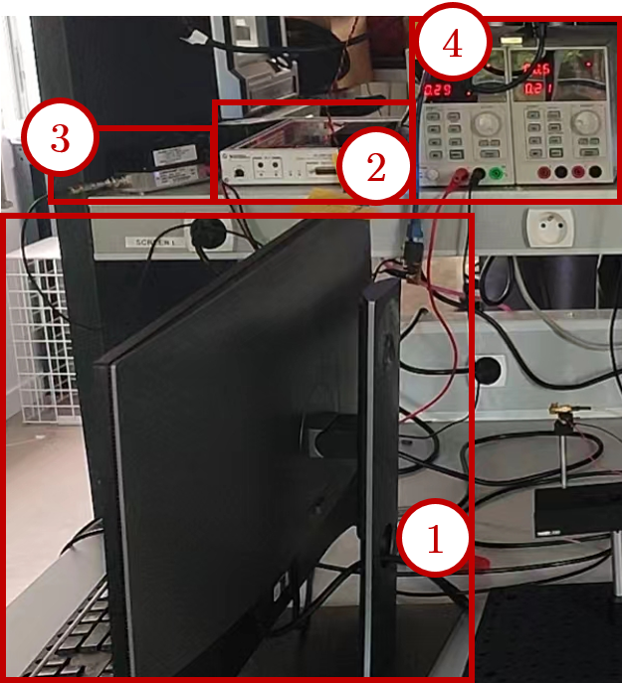
(a) Control area of the ISAC prototype, with ① the control computer for signal modulation and post-processing, ② the USRP X300, ③ a power amplifier for transmit signal amplification and ④ the power supply.
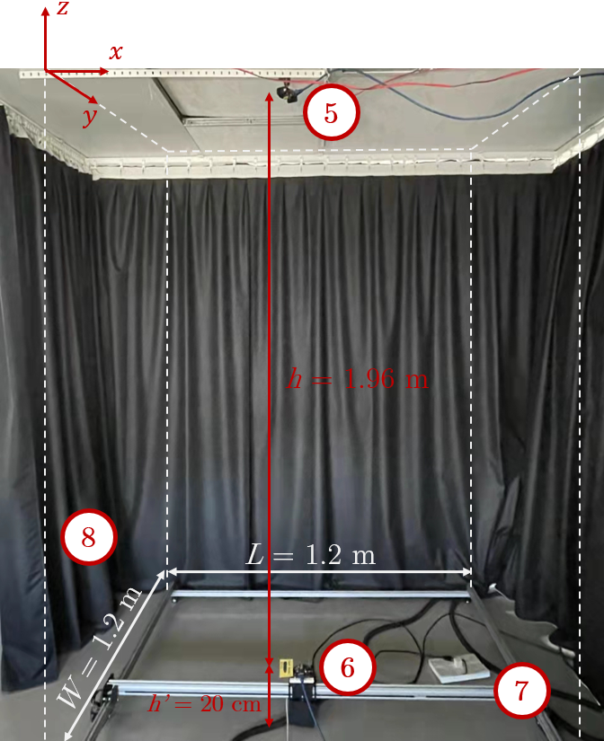
(b) Test area of the ISAC prototype, with ⑤ the transmit optical antenna, ⑥ the receive optical antenna, ⑦ a double rail to position the receive optical antenna and ⑧ black curtains delimiting the test area.
Figure 14: Example of testbed for RSS-based positioning performance evaluation.

Target KPIs
The proposed beam-steering-based OWP technique is eventually expected to meet the following KPIs:
- Localization accuracy:
  - Target value: <10 cm.
  - KPI definition: $ε_{90\%}$ the root mean square (RMS) error threshold under which 90% of the RMS errors on all the 2D/3D test points considered are.
- Coverage:
  - Target value: 1.6m x 1.6m at a distance of 1.8 m.
  - KPI definition: The coverage is defined as the volume in which the UE can be located with accuracy as defined above.
- Extra-latency:
  - Target value: < 10 ms.
  - KPI definition: Extra-latency is defined as the time needed to orientate the APs in all the necessary directions and then estimate the UE’s localization, including with the ML layers. However, this latency does not include the transmission latency from the UE to the AP, for further processing by the localization server, which is why it can be seen as the extra-latency added by the proposed OWP technique compared to the case it is not used.
- ISAC-compatibility:
  - Target value: Yes.
  - KPI definition: The proposed beamsteering-based OWP technique should not substantially degrade the communication performance of the OPTI-6G system (see D3.1 for more details about this communication function).

Potential Risks
Risks in Using ANN for Localization
- Data Collection: The training phase requires extensive data collection at known reference points, which can be time-consuming, particularly in large or complex environments.
- Computational Complexity: Training deep ANN models can be computationally intensive, and real-time localization using large networks may require significant processing power.
- Generalization: ANN models trained in one environment may not generalize well to other environments without retraining, limiting their applicability in different settings.
- RSS localization in OWC is highly sensitive to environmental factors such as lighting conditions, reflections from walls or objects, and interference from ambient light sources (e.g., sunlight, fluorescent lights). These factors can introduce inaccuracies in the received signal strength. Furthermore, in environments where objects or people move frequently, the signal strength may fluctuate, causing inaccuracies in the localization process. This is especially relevant in OWC systems, where line-of-sight conditions can easily be interrupted by human activity. In indoor OWC systems, multipath reflections from walls, floors, and other surfaces can affect RSS measurements, leading to inaccurate distance estimation. This is particularly challenging in complex indoor environments with many reflective surfaces.

Tests Principles and Test Plans
The detailed test plans that will be put in place to validate the proposed RSS-based OWP technique will be detailed in Deliverable D4.3, but a general outline of these plans can already be proposed, based on initial validation tests that have been carried out using the test bench described in Section 4.3 (see [SHI24] for more details).
These validation tests broadly consist in validating the accuracy, latency and positioning coverage of the proposed method. To this end:
- The UE is successively positioned at different locations, the coordinates of which are known (using external sensors, such as a laser rangefinder, and/or from the reference of the double axis plotter, which is programmable).
- At each location, a position estimation process is then performed, to obtain an estimate of the UE coordinates.
- This estimate is compared with the actual coordinates to obtain an RMS error.
- At the same time, a timer is triggered to determine the latency of the positioning measurement.
- The empirical CDF of all these RMS errors is then evaluated, to determine the accuracy metric $ε_{90\%}$, defined in Section 4.4. An average latency can also be defined from the latency measurements made for each location.
- It should be noted that some of the locations tested can later be used as training data for the ML methods tested.
Figure 15 shows an example of a 2D positioning test result obtained during an initial validation campaign of the RSS-based OWP technique without ML but with a deterministic correction method. These results are represented in Figure 4.6(a) as a top view of the $u_{x}$-$u_{y}$ reception plane in which the UE can move. Its actual positions are shown in blue, while estimated positions are shown in red (before correction) and in black (after correction), and linked to the actual positions to which they correspond by a dotted line. They can also be represented as in Figure 13, as an empirical CDF, which enables to determine the $ε_{90\%}$ metrics, reaching in this example 5.9 cm after correction (yellow curve).
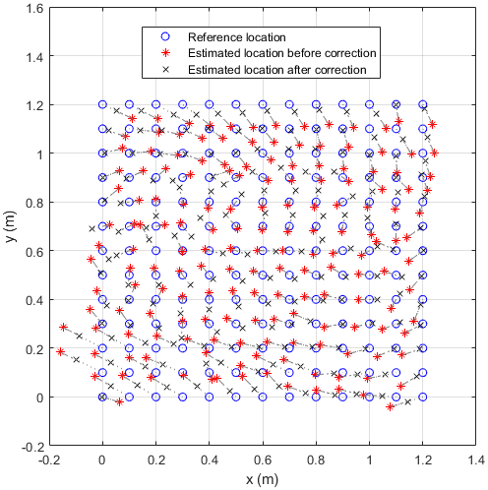 | 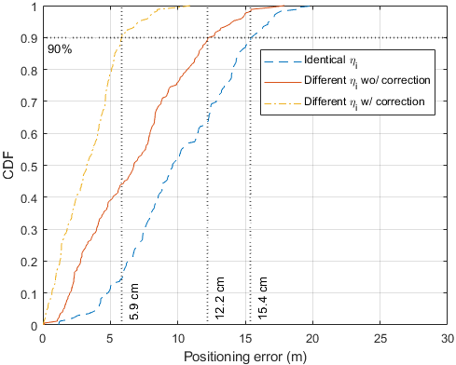
(a) | (b)
Figure 15: Example of expected test results (2D positioning case).

UE Localization Sensing based on the Modulation of the Orientation of Optical Sources

Introduction
In the world of OWC, directed beams using directional emission patterns have been used for several years for point-to-point links. The related developments have been pushed by the free space optics (FSO) domain [KAY18], that aims at high data rate connections with lasers in many fields like space applications, inter-buildings communications, and unnamed aerial vehicle transmissions for example. However, directional beams are now also widely explored for all kinds of OWC applications, including indoors [ABU22]. Advantages are numerous, like minimizing multipath dispersion, potential extension of coverage area, dynamic network reconfiguration with minimization of handover, and high improvement of signal-to-noise ratio (SNR).
Several beam-steering techniques have therefore been proposed for OWC, including gimbals, micro-mirrors, liquid crystals, and phased arrays [KAY18], depending on the necessary steering range and speed. Although each method offers its own advantages and limitations, one common challenge is that the emitter must know accurately the position of the targeted user. This position can be estimated independently of the data communication function using OWP techniques, but as highlighted in Table 1, a growing body of research is now exploring the combination of the two functions in an ISAC approach [KOU21, YAN23, SHI24].
In any case, as pointed out in Section 2.2, most of current OWP methods require the use of several APs and/or several PD at the UE level to operate, as well as the knowledge of the transmitted optical power, and are sensitive to the orientation of the receiver. These are the main limitations we propose to address in this section, by exploiting the possibility to modulate the orientation of one or several optical sources thanks to beam-steering.
In a recent study, Wang et al. [WAN24] went in a similar direction, associating a single optical source with a UE equipped with a PD which orientation can be modulated. By applying four different rotations to this PD, it is then possible to perform RSS-based 2D positioning with cm-level accuracy, without the need to know the transmitted optical power. However, the use of such a receiver can be restrictive in practice, particularly in terms of size and complexity of implementation.
In this section, we exploit instead the possibility, provided by beam-steering, to modulate the orientation of a source to propose a fully new hybrid RSS and AoA positioning method, where only one pair of AP-UE is needed for 2D positioning (instead of at least three APs in the state-of-the-art) and two APs are needed for 3D positioning).
After outlining the operating principles of this method in Section 5.2, we detail its architecture for the OPTI-6G system and a first version of test bench in Section 5.3 and 5.4 respectively, before listing the constraints that will have to be met for fusion with other OWP techniques in Section 5.5, along with the target KPIs, potential risks and an initial vision of the testing plan in Sections 5.6, 5.7 and 5.8 respectively.

Theoretical basis

Assumptions and Modelling

Geometrical modelling
From a theoretical point of view, the role of the OWP technique proposed here is to estimate, in a room of dimensions $L×W×H$, the position of a UE equipped with at least one PD, using APs equipped each with at least one optical source which orientation can be modulated. Such a system can therefore be geometrically modelled as in Figure 16, which is similar to Figure 17, except that the angle of emission between the $j$-th AP and the UE is now noted $ϕ_{j,i}$, where the index $i$ denotes the different possible orientations of the optical sources, given by their support vectors $n_{j,i}$. Note also that for clarity, only two APs are represented in Figure 16, but three or more APs could of course be used if necessary.
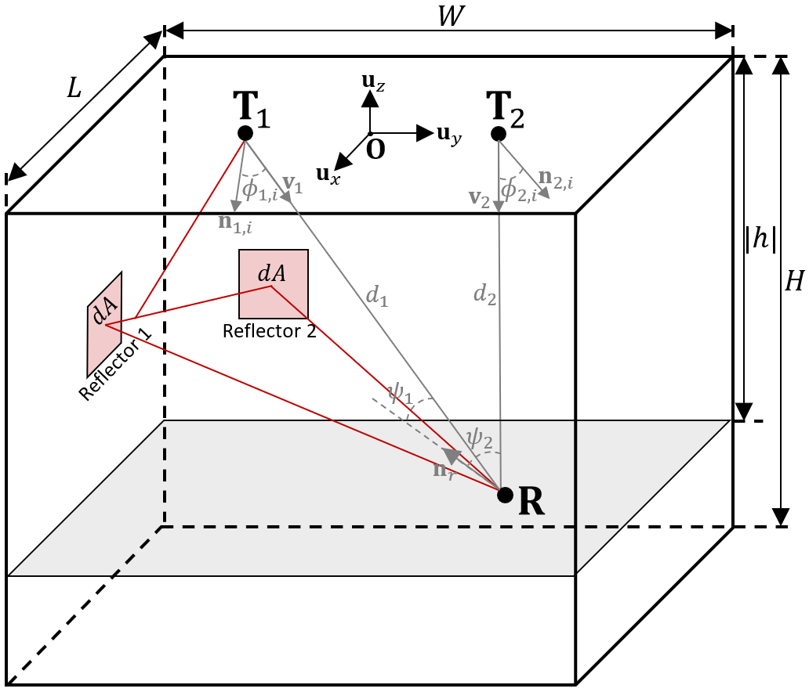
Figure 16: Geometric configuration of the proposed system and notations (at the exception of the polar angles $θ_{1,i}$ and $θ_{2,i}$, not represented for the sake of readability).
The two APs here considered are respectively placed at points $T_{1}={\left[x_{1},y_{1},z_{1}\right]}^{T}$ and $T_{2}={\left[x_{2},y_{2},z_{2}\right]}^{T}$, whereas the center of the UE’s PD is placed at a point $R$ with unknown coordinates ${\left[x,y,z\right]}^{T}$. When they are in line-of-sight (LOS), the optical sources and the photodetector are thus separated by respective distances $d_{1}$ and $d_{2}$, given by (5.1), along unit vectors $v_{1}$ and $v_{2}$, defined in the case of the first AP as:
$$v_{1}=\frac{R-T_{1}}{\left\|R-T_{1}\right\|}=\frac{1}{d_{1}}⋅{\left[x-x_{1},y-y_{1},z-z_{1}\right]}^{T}.$$ | (5.1)
At each instant, the optical sources and the PD are oriented in independent directions defined respectively by the unit vectors normal to their surfaces $n_{1,i}$, $n_{2,i}$ and $n_{r}$. The positioning method proposed here is then based on modulating the orientation of the optical sources, i.e. on modulating $n_{1,i}$ and $n_{2,i}$.
For notation purpose, we now assume that:
$$n_{1,i}={\left[a_{1,i}, b_{1,i}, c_{1,i}\right]}^{T},$$ | (5.2)
with $\sqrt{a_{1,i}^{2}+b_{1,i}^{2}+c_{1,i}^{2}}=1$ since $n_{1,i}$ are unit vectors. Note that a similar notation may also be adopted for $n_{2,i}$, with the index ‘2’ in place of ‘1’.
It is then clear from Figure 16 that the directions of emission $v_{1}$ and $v_{2}$ from the APs towards the UE are not necessarily the same as the directions of orientation of the APs $n_{1,i}$ and $n_{2,i}$. Given the definitions of these two vectors, the angle between both directions, called angle of emission (or angle of irradiance), is in the case of $T_{1}$ such that:
$$\cos{ϕ_{1,i}}=v_{1}⋅n_{1,i}=\frac{a_{1,i}\left(x-x_{1}\right)+b_{1,i}\left(y-y_{1}\right)+c_{1,i}(z-z_{1})}{d_{1}},$$ | (5.3)
where the operator ‘$⋅$’ is the scalar product between two vectors. Similarly, note that the directions of incidence on the UE, defined by the vectors $-v_{1}$ and $-v_{2}$, and its direction of orientation, defined by the unit vector $n_{r}$ normal to its sensitive area, may be different. In such a case, they form angles noted respectively $ψ_{1}$ and $ψ_{2}$ which expressions will however not be useful and is therefore not detailed here.

Physical modelling
We now assume that the optical sources used on the APs side are oriented in known directions $i$ (i.e. following the known support vectors $n_{1,i}$ and $n_{2,i}$, as represented in Figure 16), and that it outputs a constant average optical power $P_{t}$with known but generic beam patterns $R(ϕ_{1,i},θ_{1,i})$ and $R(ϕ_{2,i},θ_{2,i})$, where $ϕ_{1,i}$ and $θ_{1,i}$ are respectively the polar and azimuth angles with reference to $n_{1,i}$ and $ϕ_{2,i}$, $θ_{2,i}$ the polar and azimuth angles with reference to $n_{2,i}$. Let us also assume that each AP may transmit its signal only during an allocated time slot, i.e. that both APs cannot emit light at the same time. In such a case, the optical signal collected by the PD on the UE side is the sum of the signal received after direct LOS propagation from the active AP, plus all the NLoS signals reaching the UE after multiple reflections, as given by relation (2.4).
Under this assumption, we can then express $H_{LOS,1}$ considering that the optical power received from the LOS path will be equal to the optical power emitted $P_{t}$, attenuated by: 1) the pattern of emission $R(ϕ_{1,i},θ_{1,i})$ depending on the direction of emission, i.e. the angles $ϕ_{1,i}$ and $θ_{1,i}$, 2) the LOS propagation distance $d_{1}$, and 3) the effective sensitive surface $A_{r,eff}(ψ_{1})$ which varies as a function of the orientation $ψ_{1}$ of the receiver with respect to the incident LOS ray. In other words, and according to [KAH97], we can say that:
$$H_{1,LOS}=\frac{R\left(ϕ_{1,i},θ_{1,i}\right)A_{r,eff}\left(ψ_{1}\right)}{d_{1}^{2}}.$$ | (5.4)
At the same time, $H_{NLOS,1}$ can be expressed as the infinite sum of propagation losses induced by the various possible paths between transmitter and receiver, not detailed here.
As we will see in Section 5.2.2, the proposed positioning method requires knowledge of the optical power received from different directions of emission $i$. In practice, these values are much easier to measure indirectly from the electrical signals produced by the PD, i.e. from the RSS, rather than directly, which would require the use of cumbersome additional equipment. At first order, the instantaneous photocurrent $I_{1,i}(t)$ output by the PD depends indeed on its instantaneous incident optical power $P_{1,i}(t)$ according to the relation:
$$I_{1,i}\left(t\right)=γ_{r}P_{1,i}\left(t\right)+n\left(t\right),$$ | (5.5)
with $γ_{r}$ the PD responsivity, in A/W, and $n\left(t\right)$ the noise added by the PD, usually modelled as additive white Gaussian noise (AWGN) [KAH97]. An estimate ${\hat{P}}_{1,i}(t)$ of $P_{1,i}(t)$ can therefore be obtained from $I_{1,i}\left(t\right)$ by simply dividing it with $γ_{r}$ which, after introduction of (2.4), gives:
$${\hat{P}}_{1,i}\left(t\right)=\frac{I_{1,i}\left(t\right)}{γ_{r}}=\left[H_{LOS,1}+H_{NLOS,1}\right]P_{t}\left(t\right)+\frac{n\left(t\right)}{γ_{r}}.$$ | (5.6)
This equation clearly highlights two fundamental elements for our positioning technique. On the one hand, it shows that the received optical power that can be estimated depends directly on $H_{LOS,1}$ (and $H_{LOS,2})$and therefore on the distance $d_{1}$ (and $d_{2}$) between transmitter and receiver, which ultimately provides crucial information for determining the position of the receiver. On the other hand, it shows that this estimate is biased by at least two sources of error: firstly, AWGN noise, and secondly, its dependence via $H_{NLOS,1}$ (and $H_{NLOS,2}$) on multipath and therefore on distances other than $d$. With these elements in mind, we can now enter the details on the proposed positioning method.

Core Principles of the Proposed Positioning Method

General case
Let an UE of unknown coordinates $R={\left[x,y,z\right]}^{T}$ and an AP equipped with an optical source $T_{1}$ which orientation can be successively changed from direction $i$ to $j$. First, we assume that the NLOS components of the optical signal received by the UE are negligible, and that the UE’s PD does not introduce any AWGN. In such a case, the estimated received optical power ${\hat{P}}_{1,i}$ is thus equal to the optical power actually received $P_{1,i}$, so we can deduce from (5.4) and (5.6) that:
$$\frac{P_{1,i}}{P_{1,j}}=\frac{R\left(ϕ_{1,i},θ_{1,i}\right)}{R\left(ϕ_{1,j},θ_{1,j}\right)},$$ | (5.7)
which is remarkable in that it only depends on the angles of emission $ϕ_{1,i}$ and $θ_{1,i}$, defined themselves by the relative position between the transmitter and the receiver, i.e. by the coordinates $x$, $y$ and $z$ of the receiver. At the same time, this ratio depends neither on the optical power emitted nor on the orientation of the receiver.
We can therefore conclude that it should be possible to find the receiver's coordinates from one or more ratios of this type. Note that this principle is valid not only for optical sources, which is the case of interest for us here, but also for other types of sources such as RF antennas. Note, in addition, that if we want to go further in our development, a more explicit form of beam pattern is needed.

Case of a Lambertian source ($x$, $y$ and $z$ unknown)
Let us now assume that the optical source $T_{1}$ is following a generalized Lambertian pattern of order $m_{1}$, which is a very common case in OWC, especially for light-emitting diodes [KAH97]. This means that the pattern of emission is now symmetrical around the optical axis of the source, i.e. only depends on $ϕ_{1,i}$ according to a cosine law of order $m_{1}$. In other words, the LOS channel gain $H_{LOS,1}$ can be expressed as in (2.3), which gives with the updated notations:
$$H_{LOS,i}=\left\{\begin{aligned}\frac{A_{r}\left(m_{1}+1\right)}{{2πd}_{1}^{2}}\cos^{m_{1}}{ϕ_{1,i}}\cos{ψ_{1}} if \left\{\begin{aligned}0≤ϕ_{1,i}≤\frac{π}{2} \\ 0≤ψ_{1}≤Ψ_{c}\end{aligned}\right. \\ 0 otherwise\end{aligned}\right. .$$ | (5.8)
By combining (5.6) with (5.8) while deliberately neglecting the NLOS channel gain and AWGN, (5.7) can then be re-expressed as follows:
$$\frac{P_{1,i}}{P_{1,j}}={\left(\frac{\cos{ϕ_{1,i}}}{\cos{ϕ_{1,j}}}\right)}^{m_{1}}.$$ | (5.9)
Using in addition (5.3), this equation can be rewritten as:
$$\frac{P_{1,i}}{P_{1,j}}={\left[\frac{a_{i}(x-x_{1})+b_{i}(y-y_{1})+c_{i}(z-z_{1})}{a_{j}(x-x_{1})+b_{j}(y-y_{1})+c_{j}(z-z_{1})}\right]}^{m_{1}},$$ | (5.10)
which clearly shows the dependence of the ratio of received powers with the receiver's coordinates, and not with the transmitted optical power or the orientation of the receiver.
Let us now introduce the factor $K_{1,ij}$, defined from (5.10) as:
$$K_{1,ij}={\left(\frac{P_{1,i}}{P_{1,j}}\right)}^{\frac{1}{m_{1}}}=\frac{a_{i}(x-x_{1})+b_{i}(y-y_{1})+c_{i}(z-z_{1})}{a_{j}(x-x_{1})+b_{j}(y-y_{1})+c_{j}(z-z_{1})}.$$ | (5.11)
These factors are in practice known as they can be calculated from the estimates of the received optical powers in the different directions of emission. By reformulating (5.11), we can then obtain the following simple linear equation with unknowns $x$, $y$ and $z$:
$$\left(a_{1,i}-K_{1,ij}a_{1,j}\right)(x-x_{1})+\left(b_{1,i}-K_{1,ij}b_{1,j}\right)(y-y_{1})+\left(c_{1,i}-K_{1,ij}c_{1,j}\right)(z-z_{1})=0.$$ | (5.12)
In order to find the values of these unknowns, it is therefore necessary to get other linear equations of similar form, which can be achieved by orienting the transmitters $T_{1}$ and $T_{2}$ in other directions. Note indeed that all the previous equations remain valid when considering transmitter $T_{2}$, by simply replacing the index ‘1’ by ‘2’. In any case, with this generic equation in mind, the challenge is now to define how many APs and how many different orientations for each AP are needed to achieve a 2D and 3D positioning of the UE.

Case of a Single Lambertian Source

Is 3D positioning possible?
In this section, we consider only a single AP equipped with a Lambertian source. In order to simplify notation, without losing generality, we drop the index ‘1’ (i.e. $T_{1}=T, a_{1,i}=a_{i}, b_{1,i}=b_{i}, c_{1,i}=c_{i}, m_{1}=m$ and $K_{1,ij}=K_{ij}$) and consider that this AP is located at the origin of the main frame, i.e. $T=\left[0,0,0\right].$ In such a case, only a single equation like (5.12) can be built from two different orientations $i$ and $j$, which is not sufficient to find the $x$, $y$ and $z$ coordinates of the UE. We need therefore to add two more equations, which means we have to consider one additional random orientation $k$, and the resulting ratios $K_{ij}$, $K_{jk}$ and $K_{ik}$ so that we can eventually express the corresponding equations (5.12) in the following matrix form:
$$AR=0_{3,1},$$ | (5.13)
with $R={\left[x,y,z\right]}^{T}$, $0_{3,1}={\left[0,0,0\right]}^{T}$ and:
$$A=\left[\begin{matrix}a_{i}-K_{ij}a_{j} & b_{i}-K_{ij}b_{j} & c_{i}-K_{ij}c_{j} \\ a_{j}-K_{jk}a_{k} & b_{j}-K_{jk}b_{k} & c_{j}-K_{jk}c_{k} \\ a_{i}-K_{ik}a_{k} & b_{i}-K_{ik}b_{k} & c_{i}-K_{ik}c_{k}\end{matrix}\right].$$ | (5.14)
This system has a unique solution if and only if the determinant of $A$, noted $\det{A}$, is non-zero. In order to calculate this determinant, we can build $A$ with the vectors of the canonical basis $B=\{u_{x},u_{y},u_{z}\}$ of the main frame $F=\left(T, B\right)$ instead of random orientations. From a purely mathematical point of view, choosing these three different orientations as the vectors of $B$ does not introduce any limitations, as any vector in $R^{3}$ can be expressed as a linear combination of $u_{x}$, $u_{y}$ and $u_{z}$, so the resulting matrix $A$ would have the same determinant as the one obtained with the canonical basis.
Knowing that $u_{x}=\left[1,0,0\right]$, $u_{y}=[0,1,0]$ and $u_{z}=[0,0,1]$, and assuming $n_{i}=u_{x}$, $n_{j}=u_{y}$ and $n_{k}=u_{z}$, we can rewrite $A$ from (5.14) as:
$$A=\left[\begin{matrix}1 & -K_{ij} & 0 \\ 0 & 1 & -K_{jk} \\ 1 & 0 & -K_{ik}\end{matrix}\right],$$ | (5.15)
which determinant is:
$$\det{A}=-K_{ik}+K_{ij}K_{jk}$$  $$⟺\det{A}=-{\left(\frac{\cos{ϕ_{i}}}{\cos{ϕ_{k}}}\right)}^{\frac{1}{m}}+{\left(\frac{\cos{ϕ_{i}}}{\cos{ϕ_{j}}}\right)}^{\frac{1}{m}}{\left(\frac{\cos{ϕ_{j}}}{\cos{ϕ_{k}}}\right)}^{\frac{1}{m}}$$  $$⟺\det{A}=-{\left(\frac{\cos{ϕ_{i}}}{\cos{ϕ_{k}}}\right)}^{\frac{1}{m}}\left(-1+1\right)=0.$$ | (5.16)
We can deduce that as such, the system (5.13) with unknowns $x$, $y$ and $z$ and matrix $A$ defined by (5.14) has no unique solution, whatever the orientations of the source. It is therefore necessary to formulate additional hypotheses in order to make this system solvable.

Case of 2D positioning
Several different assumptions could be used to make the system formed by (5.13) and (5.14) solvable. First, we focus on the case where the vertical distance $z$ between the AP and the UE is known, e.g. $z=h$, with $h<0$. Such an assumption may seem restrictive but is in practice verified in many cases (e.g. mobile robot in a plane) or can at least be validated with additional sensors.
In this case, (5.13) has only two unknown variables left ($x$ and $y$) and therefore only needs two equations to be solved, which can for example be obtained with the ratios $K_{ij}$ and $K_{ik}$. Solving the resulting system by simple substitution gives eventually:
$$x=\frac{\left(K_{ij}b_{k}-b_{i}\right)\left(c_{i}-K_{ij}c_{j}\right)-(K_{ij}b_{j}-b_{i})(c_{i}-K_{ik}c_{k})}{\left(K_{ik}b_{k}-b_{i}\right)\left(K_{ij}a_{j}-a_{i}\right)-(K_{ij}b_{j}-b_{i})(K_{ik}a_{k}-a_{i})}h,$$ | (5.17)
and
$$y=\frac{\left(K_{ik}a_{k}-a_{i}\right)\left(c_{i}-K_{ij}c_{j}\right)-(K_{ij}a_{j}-a_{i})(c_{i}-K_{ik}c_{k})}{\left(K_{ik}a_{k}-a_{i}\right)\left(K_{ij}b_{j}-b_{i}\right)-(K_{ij}a_{j}-a_{i})(K_{ik}b_{k}-b_{i})}h.$$ | (5.18)
In other words, by orienting the optical source of the AP in three different directions, and assuming that the $z$ coordinate of the UE is known, it is then possible to estimate its remaining coordinates $x$ and $y$, regardless of the transmitted optical power and the orientation of the UE.
It may be noted, however, that (5.17) and (5.18) are only valid as long as the optical power received from the Lambertian source is non-null, i.e. as long as the angle of emission $ϕ_{i}$ of the source is lower than 90° and/or the angle of incidence is lower than the FoV of the PD. It is also important to note that this position estimate actually neglects the NLOS components of the received optical signals, as well as the AWGN added by the UE's PD, which can therefore have an impact on the positioning error.

Case of Two Lambertian Sources
We now consider the case where two APs, and therefore two optical sources $T_{1}$ and $T_{2}$, are used, as shown in Figure 16. The notations used here are thus the same as in Section 5.2.1, but we use in addition the mute index $n$ to refer to the $n$-th optical source (i.e. source $n=1$ or $n=2$). Then, we can observe that (5.12) can be re-expressed as follows:
$$\left(a_{n,i}-K_{n,ij}a_{1,j}\right)x+\left(b_{n,i}-K_{n,ij}b_{n,j}\right)y+\left(c_{n,i}-K_{n,ij}c_{n,j}\right)z=\left(a_{n,i}-K_{n,ij}a_{n,j}\right)x_{n}+\left(b_{n,i}-K_{n,ij}b_{n,j}\right)y_{n}+\left(c_{n,i}-K_{n,ij}c_{n,j}\right)z_{n}.$$ | (5.19)

Using the following notations:
$$α_{n,ij}=a_{n,i}-K_{n,ij}a_{n,j}$$  $$β_{n,ij}=b_{n,i}-K_{n,ij}b_{n,j}$$  $$γ_{n,ij}=c_{n,i}-K_{n,ij}c_{n,j}$$  $$B_{n,ij}=\left(a_{n,i}-K_{n,ij}a_{n,j}\right)x_{n}+\left(b_{n,i}-K_{n,ij}b_{n,j}\right)y_{n}+\left(c_{n,i}-K_{n,ij}c_{n,j}\right)z_{n},$$ | (5.20)
equation (5.19) can therefore be expressed as:
$$α_{n,ij}x+β_{n,ij}y+γ_{n,ij}z=B_{n,ij}$$ | (5.21)
The aim is now to form three independent equations similar to (5.21), which in practice can be achieved by considering two sources, the first one $T_{1}$ oriented successively in three directions $i$, $j$ and $k$, and the other $T_{2}$ in two directions $i$ and $j$. In such a case, we can express the resulting equations in the following matrix form:
$$AR=B,$$ | (5.22)
with $R={\left[x,y,z\right]}^{T}$ and:
$$A=\left[\begin{matrix}α_{1,ij} & β_{1,ij} & γ_{1,ij} \\ α_{2,ij} & β_{2,ij} & γ_{2,ij} \\ α_{1,ik} & β_{1,ik} & γ_{1,ik}\end{matrix}\right] and B=\left[\begin{aligned}B_{1,ij} \\ B_{2,ij} \\ B_{1,ik}\end{aligned}\right].$$ | (5.23)
Where the variables of type $α$, $β$, $γ$ and $B$ are as defined by (5.20).
If solutions to this linear system exist, they can eventually be obtained using the Cramer method, according to which:
$$x=\frac{\det{A_{1}}}{\det{A}}, y= \frac{\det{A_{2}}}{\det{A}} and z=\frac{\det{A_{3}}}{\det{A}},$$ | (5.24)
with
$$A_{1}=\left[\begin{matrix}B_{1,ij} & β_{1,ij} & γ_{1,ij} \\ B_{2,ij} & β_{2,ij} & γ_{2,ij} \\ B_{1,ik} & β_{1,ik} & γ_{1,ik}\end{matrix}\right],$$  $$A_{2}=\left[\begin{matrix}α_{1,ij} & B_{1,ij} & γ_{1,ij} \\ α_{2,ij} & B_{2,ij} & γ_{2,ij} \\ α_{1,ik} & B_{1,ik} & γ_{1,ik}\end{matrix}\right],$$  $$A_{3}=\left[\begin{matrix}α_{1,ij} & β_{1,ij} & B_{1,ij} \\ α_{2,ij} & β_{2,ij} & B_{2,ij} \\ α_{1,ik} & β_{1,ik} & B_{1,ik}\end{matrix}\right].$$ | (5.25)

Conclusions and Important Notes
As pointed out in Section 2.2.4.2, the common RSS-based 2D positioning method relies on the measurement, by the UE, of the optical power it receives from at least three different and spatially distinct APs. As a comparison, the method we propose requires just one optical source on the AP side, and one simple PD on the UE side, which is its main advantage compared to the state-of-the-art. This comes eventually from the fact that changing the orientation of a single source is theoretically equivalent to using virtual but distinct optical sources and then applying conventional RSS equations to recover the UE coordinates. Similar reasoning can be applied to explain the differences between the proposed method and conventional RSS for the 3D case.
In any case, another major difference between the proposed method and conventional RSS is that the transmitted optical power does not need to be known, and that the orientation of the UE does not influence in theory the positioning process. Note in addition that this orientation could actually be estimated using a third AP, following a process not detailed here, which could be applied to any RSS-like OWP method.
It may however be noted that the equations derived above are valid only in the ideal case where NLOS paths and AWGN are neglected. When considering these phenomena, the received optical power estimated from the received electrical signals produced by the PD (see (5.6)) will be biased compared to the LoS optical power needed in the positioning equations (5.24), which will eventually translate into positioning errors.
In order to mitigate these errors, common estimation techniques, such as root mean square estimators (RMSE) can be used, as well as more advanced machine learning (ML) techniques. ML techniques can indeed be very useful to provide correction techniques that adapt themselves depending on the actual position of the UE. For example, zones with higher NLoS paths (e.g. close to walls) may experience higher positioning errors, which could be better corrected by implementing an adapted and adaptive ML-based estimator. In practice, we intend to explore various ML-techniques such as $K$-nearest neighbor (KNN), weighted KNN (WKNN), improved WKNN (IWKNN), random forest (RF), extreme decision trees (EDT), gradient boosting (GB), support vector machine (SVM), multi-layer perceptron (MLP) or Gaussian process (GP).

Localization System Architecture
In practice, the new OWP method proposed here will be implemented during the OPTI-6G project according to the architecture detailed in Figure 17, where the major components for the proposed beam-steering-based OWP technique to operate properly are in bold font.
On the AP side, the downlink (DL) data payload is processed and modulated by the central unit, before being converted in a baseband analog signal by a digital-to-analog converter (DAC) after up and down-conversion, note represented in Figure 17. This analog signal is then converted in the optical domain by the LED of the optical front-end (OFE) of the AP, after first amplification and filtering by its analog front-end (AFE). In practice, this OFE (or at least its LED) has to be oriented in three consecutive directions for the proposed OWP method to work.
The optical signals transmitted are then successively collected on the UE side by the PD of its OFE, amplified and processed by its AFE and then converted in the digital domain by an analog-to-digital converter (ADC). The central unit of the UE then processes this digital signal to recover the transmitted DL data, while estimating the three consecutive RSS at the same time. The resulting RSS estimates may then:
- Either be directly embedded in the uplink (UL) data payload sent by the UE to the AP, following a transmission-reception chain similar as that just described,
- Or first be processed by the UE’s central unit so that it can estimate its own localization, before embedding the resulting coordinates in the UL data payload then sent to the AP.
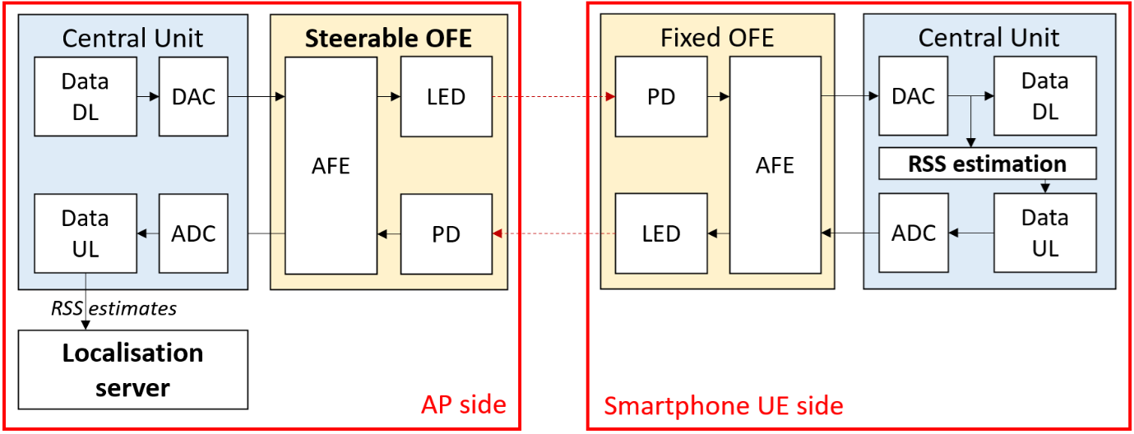
Figure 17:Architecture of the OPTI-6G system including the proposed beam-steering-based OWP system (the up and down-converters are hidden and the central units are simplified to ease readability).
In both cases, the signal received by the AP is, after conversion in the digital domain at the central unit level, processed to recover the UL data payload, including the localization-related data, that are then sent to the localization server for fusion with the localization data given by the other methods (see Section 6).

Localization System design
An initial test bench has been designed and built to perform, first the standalone validation tests of the proposed beam-steering-based OWP technique without integrating the other core bricks of the OPTI-6G project. This test bench, shown in Figure 18, relies on the AP side on an Osram LZ1-00R702 dual junction infrared LED ①, driven at 300 mA and operating at 940 nm. This LED is installed on a homemade mechanical stage ②, itself fixed to a bracket ③ at 2.23 m height.
This stage is designed to control the orientation of the LED’s optical axis with two rotational degrees of freedom around the $u_{x}$ and the $u_{y}$ axis. It consists of two orthogonal Thorlabs PRMTZ8/M motorized precision rotation stages ④, controlled themselves by a computer ⑤ via Thorlabs KDC101 servo motor controllers ⑥. As the LED is located at the center of rotation of this mechanical stage, any change in its orientation does not change its position.
On the UE side, the receiver is a custom-made opto-electronic front-end composed of an Osram BPX61 silicon PD and a transimpedance stage ⑦, which output voltage is recorded by a Keithley 2100 high-precision voltmeter ⑧ and then post-processed with the computer ⑤ to estimate the receiver’s location. This front-end is attached to the gripper of a Universal Robots URS robot arm ⑨, which position, and orientation can be controlled by the computer ⑤.
This first test bench offers many advantages, starting with its great flexibility. In particular, the use of the robotic arm means that several actual positions of the UE can be tested automatically and quickly with great precision, over an area of around 2 m², without having to change the position of the center of the robotic arm. The test area can then be extended by simply changing this position manually. The test bench can also be easily integrated into the future OPTI-6G demonstrator, since only the beam-steering system needs to be added, the other equipment already being required to perform the system’s other functions.
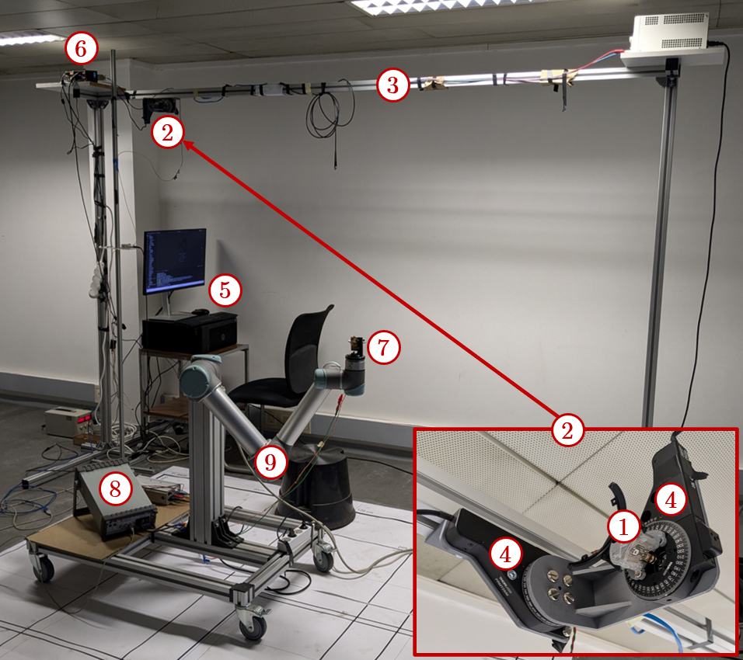
Figure 18: First test bench implemented to validate the proposed beam steering-based OWP technique.
However, as it stands, this test bench does not entirely meet the KPIs listed in Section 5.6, as it is, on the one hand, standalone. Therefore, at this stage, it does not allow data transmission and is not interfaced with the localization server for the fusion of the various positioning techniques (see Section 5.5 for more details on the constraints that will have to be met in this respect).
On the other hand, and more importantly, the mechanical beam-steering system implemented was primarily designed to enable very precise orientation of the AP LED, to the detriment of the transition speed from one orientation to the next. This point needs to be improved in order to meet the latency KPI listed in Section 5.6 (20 ms). It should be noted, however, that from a software point of view, initial tests of this bench show that position estimation including ML layers but neglecting transition times between orientations has a duration of the order of ten milliseconds, thus completely in line with the latency target.

Target KPIs
The proposed beam-steering-based OWP technique is eventually expected to meet the following KPIs:
- Localization accuracy:
  - Target value: $ε_{90\%}<$ 10 cm
  - KPI definition: $ε_{90\%}$ the root mean square (RMS) error threshold under which 90% of the RMS errors on all the 2D/3D test points considered are.
- Coverage:
  - Target value: 2x2x2 m³ with a single AP.
  - KPI definition: The coverage is defined as the volume in which the UE can be located with accuracy as defined above.
- Extra-latency:
  - Target value: 20 ms.
  - KPI definition: Extra-latency is defined as the time needed to orientate the APs in all the necessary directions and then estimate the UE’s localization, including with the ML layers. However, this latency does not include the transmission latency from the UE to the AP, for further processing by the localization server, which is why it can be seen as the extra-latency added by the proposed OWP technique compared to the case it is not used.
- ISAC-compatibility:
  - Target value: Yes.
  - KPI definition: The proposed beam-steering-based OWP technique should not substantially degrade the communication performance of the OPTI-6G system (see D3.1 for more details about this communication function).

Potential Risks
Three main risks have been identified regarding the practical implementation of the proposed beam-steering-based OWP technique within the OPTI-6G system:
- Risk 1: The positioning accuracy target is not reached. Although this risk is real, first test show that in the 2D case, without optimized orientations of the optical source but using ML techniques, the $ε_{90\%}$ accuracy is below 5 cm over a coverage area of 1.8 x 1.8 m².
- Risk 2: The positioning latency target is not reached. This risk is identified as the main risk, as the overall extra-latency, as defined in Section 5.6, strongly depends on the transition times between consecutive orientations of the APs which has, at this stage, not been optimized. More advanced mechanical and optical beam-steering solutions are currently under study to reduce these transition times.
- Risk 3: The ML training phase is too constraining for real-world applications. ML is critical for any OWP solution to cope with the specificities of different environments, especially with the noise and NLoS paths, but needs a training phase that may be too long and constraining for real-world applications. To mitigate this issue, we investigate solutions for the generation of artificial training data and focus on ML techniques efficient even with relatively small training database.

Tests Principles and Test Plans
The detailed test plans that will be put in place to validate the proposed beam-steering-based OWP technique will be detailed in Deliverable D4.3, but a general outline of these plans can already be proposed, based on the initial validation tests that have been carried out using the test bench described in Section 5.4.
These validation tests broadly consist in validating the accuracy, latency and positioning coverage of the proposed method. To this end:
- The UE is successively positioned at different locations, the coordinates of which are known (using external sensors, such as a laser rangefinder, and/or from the reference of the robotic arm and the coordinates of its gripper, which are programmable).
- At each location, a position estimation process is then performed, to obtain an estimate of the UE coordinates.
- This estimate is compared with the actual coordinates to obtain an RMS error.
- At the same time, a timer is triggered to determine the latency of the positioning measurement.
- The empirical CDF of all these RMS errors is then evaluated, to determine the accuracy metric $ε_{90\%}$, defined in Section 5.6. An average latency can also be defined from the latency measurements made for each location.
- It should be noted that some of the locations tested can later be used as training data for the ML methods tested.
Figure 18 shows an example of a 2D positioning test result obtained during an initial validation campaign for the proposed method. These results are represented as a top view of the $x$-$y$ reception plane in which the UE can move. Its actual positions are shown in blue, while estimated positions are shown in red, and linked to the actual positions to which they correspond by a dotted line. Note that some test points are not shown, as they were used as training data for the ML method used. Ultimately, the accuracy metric in this case is $ε_{90\%}$ = 2.8 cm, while the average latency is of the order of ten ms (no systematic evaluation during this first test campaign).
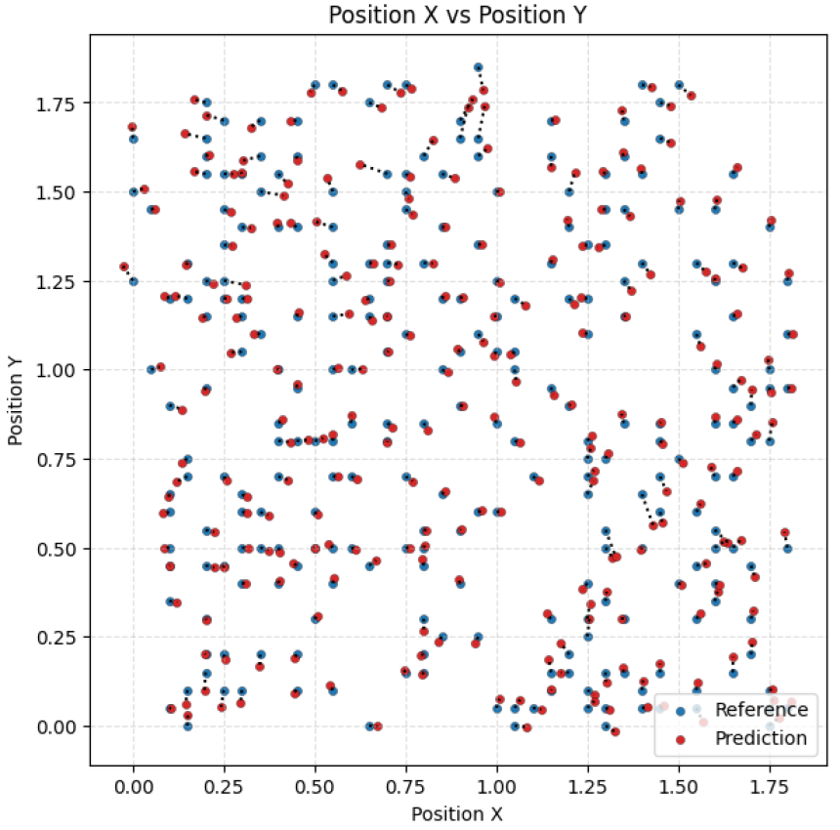
Figure 19: Example of expected test results (2D positioning case).

Localisation Methods Fusion Server

Localisation Fusion System Architecture
First the Anchor locations of the OWC emitter-receivers or the sub 6 GHz antennas and the measurement test locations need to be recorded on the Location Database (LD). Then the raw Time of Arrival (ToA) data from the O-RAN Compliant Remote Unit (O-RU) needs to be recorded on LD. Furthermore, the data from the LIDAR and the 360 degrees camera can also be recorded on LD. Then the Anchor locations and the data (raw ToA, LIDAR and 360° camera) need to be processed on the Location Server (LS) and stored the UE data on LD. This process is shown in Figure 20.
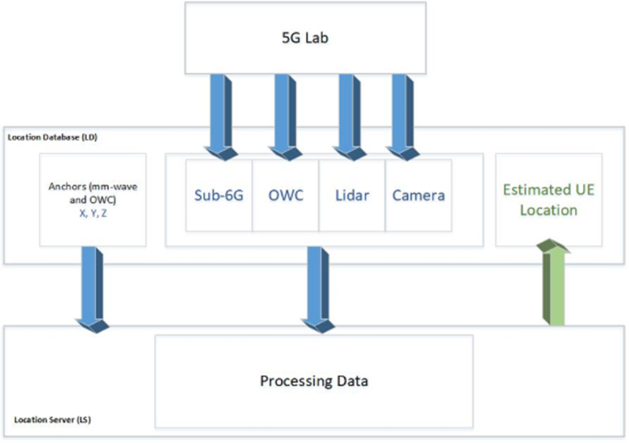
Figure 20: OWC and Sub 6 GHz antennas’ locations

Location Database
First the Anchor locations of the OWC emitter-receivers and the measurement test locations need to be recorded on the Location Database (LD).

 | x | Y | z
OWC1
OWC2
OWC3
OWC4
RU1
Table 2: Sub 6 GHz and OWC antennas’ locations
Then the raw Time of Arrival (ToA), Signal to Noise Ratio (SNR), Received Signal Strength Indication (RSSI) data from the O-RAN Compliant Remote Unit (O-RU) for each UE with Radio Network Temporary Identifier (RNTI) needs to be recorded on LD.

UE RNTI | frame | slot | sect | Time-tics (0.3 ps or 0.1 mm) | SNR | RSSI
Table 3: Raw OWC data SNR, RSSI …
The ToA data is processed to produce the x, y z location of each UE with RNTI.

UE RNTI | X | Y | Z
Table 4: Estimated UE’s location by using OWC using ToA

The RSS is data is processed to produce the x, y z location of each UE with RNTI.

Ref UE | RSS1 | RSS2 | RSS3 | RSS4 | RSS5 | RSS6 | X | Y | Z | Time
UE 1
UE 2
Table 5: OWC data and Reference location of UE

The RSS is data that is processed to produce the x, y z location of each UE with RNTI.

UE | X | Y | Z
UE 1
UE 2
Table 6: Estimated UE’s location by using OWC using RSS

Camera | File location | X | Y | Z | Time
Cam01
Cam02
Table 7: Camera data and actual location

LIDAR | File1 | File2 | X | Y | Z | Time
LID01
LID02
Table 8: LIDAR data and actual location

Localisation Interfaces between AoA, ToA, RSS sensors and Database
To access MySQL databases using Python, the following package needs to be installed in Linux virtual environment: PyMySQL: This package contains the PyMySQL module. It is written entirely in Python.
MySQL Server – one of the following: MySQL >= 5.5
Using: pip install PyMySQL
Parameters:
host – Host where the database server is located: Dell 730 OpenStack Server
user – Username to log in as: admin
password – Password to use: 1234
database – Database to use, None to not use a particular one.
port – MySQL port to use, default is usually OK. (default: 3306)
Example software to connect and access MySQL data can be found here:
Connect to MySQL using PyMySQL in Python - GeeksforGeeks

Graphical User Interface to Localisation

Remote access to Openstack & MySQL Database Linux Servers
To remote access the Dell 730 OpenStack Server and the Dell 740 RAN Host and MySQL database server install x2go remote access client on your Linux PC using: sudo apt-get install x2goclient.
X2go servers are already installed on the Dell 730 OpenStack Server with MySQL database server.
To Open X2GO client to create session, select the x2go application icon on PC as shown in Figure 21a and the x2go application will launch as shown in figure 21b, showing any existing sessions available to launch and allowing to create new sessions with the new session tab as shown in figure 22.
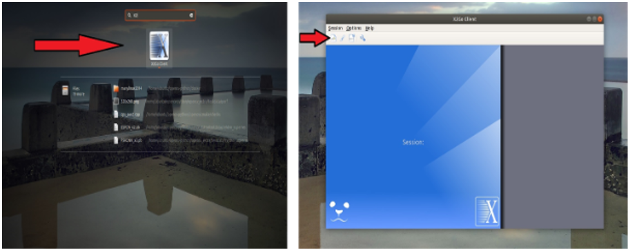
(a) X2go client icon (b) x2go client user interface
Figure 21: x2go client
In the Session name field, enter something to help differentiate between servers. Using a session name is particularly useful if you plan on connecting to multiple machines. Enter your server’s IP address in the Host field under Server. Enter the username of the server in the Login field. Select Session type choose XFCE.
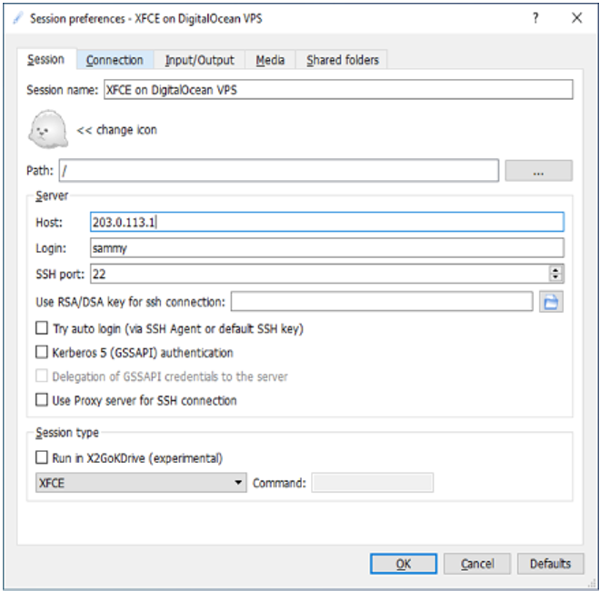
Figure 22: Creating x2go client

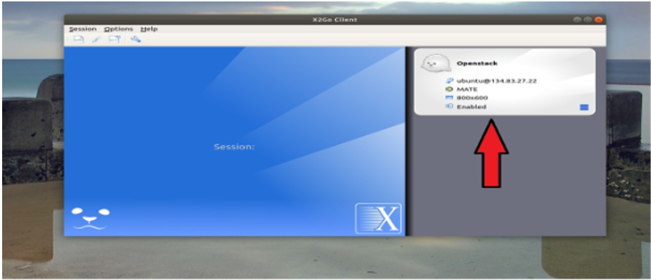
Figure 23: Access x2go client
Now session has been created on client machine, as shown in Figure 23. To start remote access double click on session and enter the password as shown in figure 24. The available Linux machines for access are the Dell 730 OpenStack Server
Whose password can be obtained on application from: john.cosmas@brunel.ac.uk
Now you have access to the remote terminal.
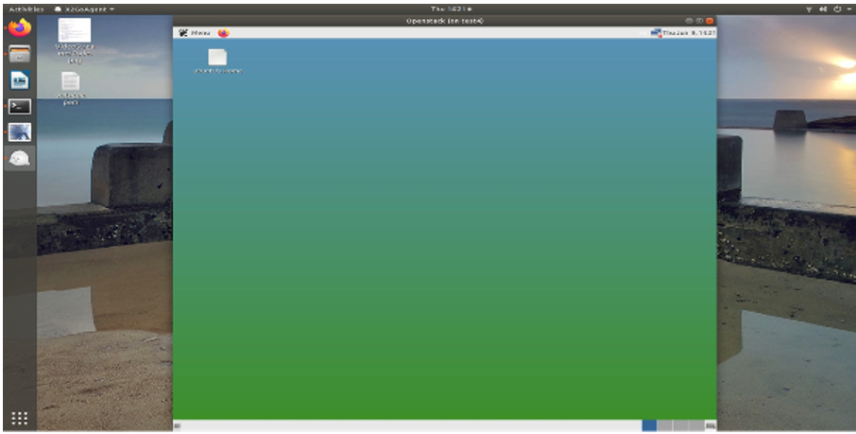
Figure 24: x2go access to Openstack server

Localisation Fusion Methodologies
The challenge in Localisation Fusion Methodologies is to obtain samples of the measurements that are synchronised with each other in time. If the measurements are not synchronised in time then virtual measurements need to be estimated from the real measurements in order for a meaningful time synchronized fusion to take place. Clearly If measurements are synchronised in time everything is made much simpler since this virtual synchronization process need not take place.

6.5.1 Uplink distance and location estimates using ToA and RSS measurements
Measuring RSS from downlink transmissions at UEs in cell-free OWC network requires each OWC antenna to successively make transmission at different times whilst all other OWC antenna are not transmitting, as illustrated in Figure 25.
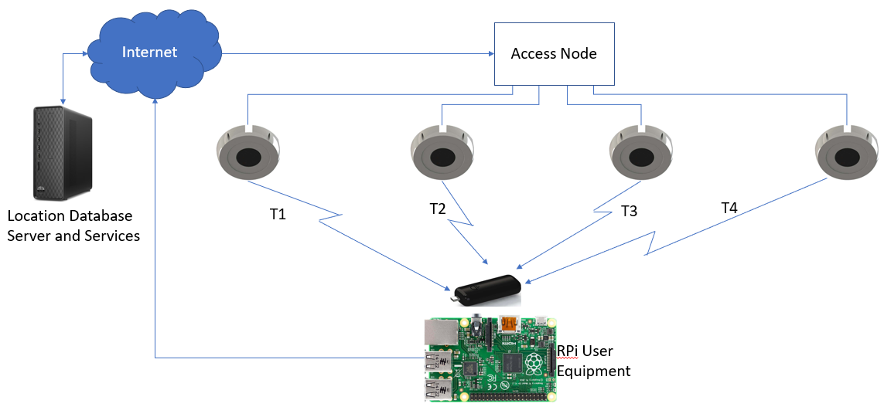
Figure 25: Measuring RSS from downlink transmissions at UEs
The concept of extrapolation to counter measurements of distance at different times requires the computation of extrapolation to time align measurements established from asynchronous sensors, as shown in Figure 26. This process to date has been limited to linear extrapolations of target positions (poses) or Inertial Measurement Units (IMU) and bearing measurements. The initial principle for the proposed asynchronous solution is to extrapolate range measurements linearly to a common point in time, when they can be processed as synchronous measurements, using efficient position estimation techniques, which introduces prediction errors [Meu22].
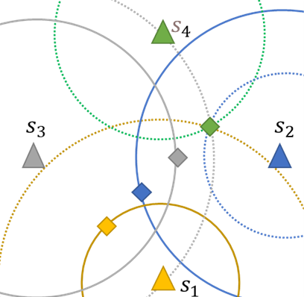
Figure 26: Extrapolation to counter measurements at different times
On the other hand, measuring RSS from uplink transmissions at the OWC antennas in Cell-free OWC network requires OWC antennas to simultaneously make measurements from a single transmission at from the UE, as illustrated in Figure 27.
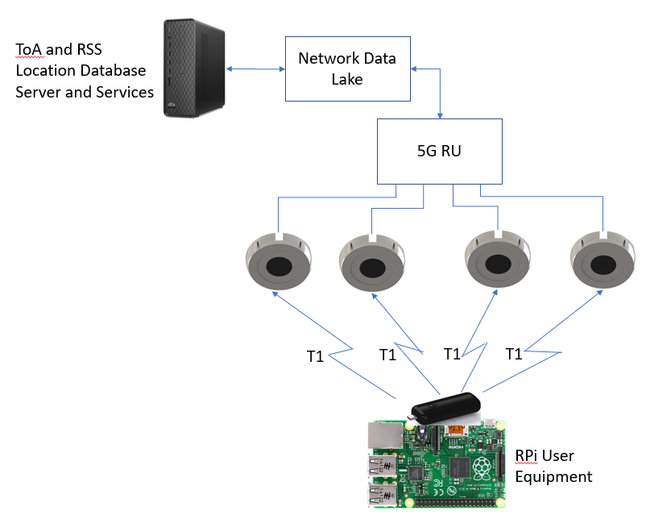
Figure 27: Measuring RSS from uplink transmissions at OWC antennas
Thus, RSS and ToA measurements can simultaneously take place with the former method measuring distance from the strength of received signal and the latter method measuring distance from the time of transmission. Fusion of these measurements can be performed without the need for time synchronisation using Artificial Intelligence which learns the accuracy of the two measurement approaches depending on their location and adds a suitable weighting to the two estimates in the averaging process.

5.6.2 Strategy for Localisation fusion using ToA and RSS data
Distance measurements from two access points limit our location to the intersection of two spheres, which is a circle. A third measurement narrows our location to just two points. A fourth measurement determines which point is our true location, [Jaw14].
Localisation of UEs within the area bounded by red lines, has LoS access to four access points and can compute its 3D position using ToA and/or RSS measurements.
Localisation of UEs outside the area bounded by red lines but within the area bounded by orange lines, have LOS access to three access points so are able to compute its 3D position using ToA and/or RSS measurements with a two-point ambiguity.
Localisation of UEs outside the area bounded by red and orange lines but within the area bounded by purple lines, have LOS access to two access points so are unable to compute its 3D position using ToA and/or RSS measurements due to too much ambiguity.
Localisation of UEs outside the area bounded by red, orange and purple lines but within the area bounded by green line boundary of the laboratory, have LoS access to one access point so are unable to compute its 3D position using ToA and/or RSS measurements due to too much ambiguity.
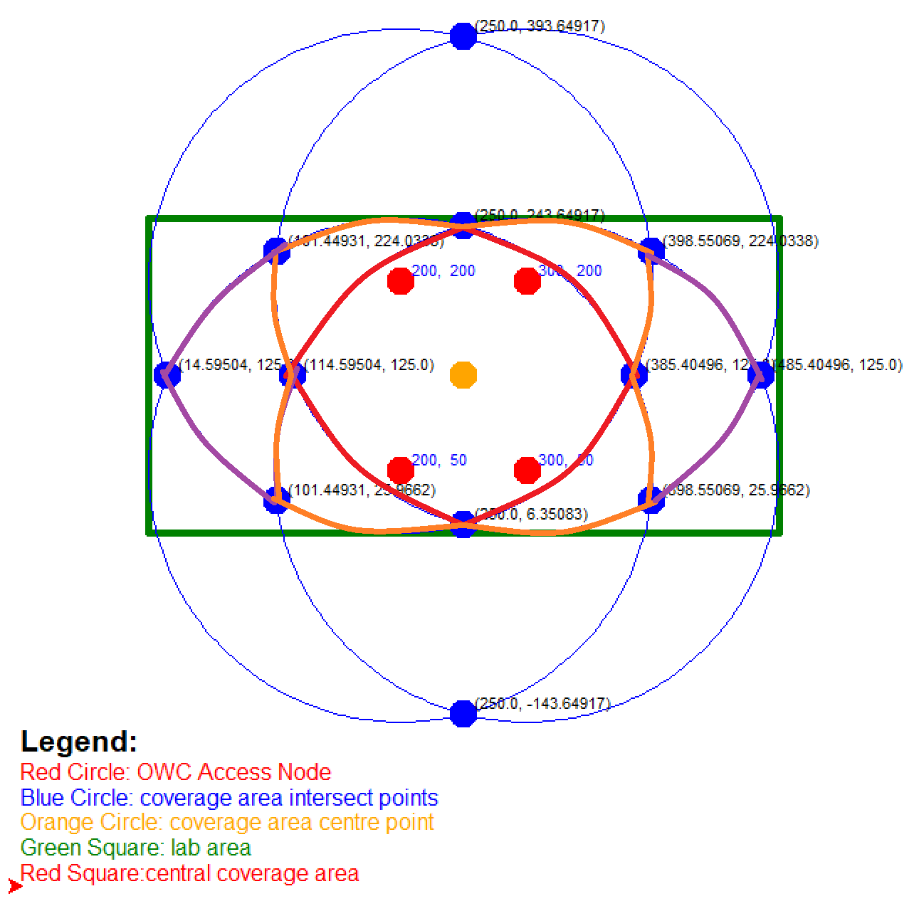
Figure 28: Area of coverage area with LoS access to N access points, where 0 < N <=4
ToA and RSS measurements of distance and location will be measured at different locations of the coverage area and accuracy, coverage and latency measured for each.

Target KPIs
The proposed fusion-based OWP technique is expected to meet the following KPIs:
- Localization accuracy:
  - Target value: $ε_{90\%}<$ 5 cm
  - KPI definition: $ε_{90\%}$ the root mean square (RMS) error threshold under which 90% of the RMS errors on all the 2D/3D test points considered are.
- Coverage:
  - Target value: 1.8x1.8x1.8 m³ from four AP.
  - KPI definition: The coverage is defined as the volume in which the UE can be located with accuracy as defined above.
  - Target value: 2.97x2.97 m² from three AP.
  - KPI definition: The coverage is defined as the area in which the UE can be located with accuracy as defined above.

- Extra-latency:
  - Target value: 5 ms.
  - KPI definition: 1ms is required to capture the distance data and 4ms required to compute the location
- ISAC-compatibility:
  - Target value: Yes.
  - KPI definition: The proposed ToA/RSS-based OWP technique does not substantially degrade the communication performance of the OPTI-6G system.

Potential Risks
Three main risks have been identified regarding the practical implementation of the proposed fusion-based OWP technique within the OPTI-6G system:
- Risk 1: The positioning accuracy target is not reached. Although this risk is real, ToA tests with sub 6GHz show that distance can be measure to 3.5 cm to 4.5 cm [COS24], the $ε_{90\%}$ accuracy is below 5 cm over a coverage area of 1.8 x 1.8 m².
- Risk 2: The positioning latency target is not reached. This risk is unlikely to be occur..
- Risk 3: The ML does not yield sufficient improvements.

Tests Principles and Test Plans
The detailed test plans that will be put in place to validate the proposed RSS and ToA fusion-based OWP technique will be detailed in Deliverable D4.3, but a general outline of these plans can already be proposed, based on the initial experiments performed on sub-6GHz distance and OWC RSS measurement tests.
These validation tests broadly consist in validating the accuracy, latency and positioning coverage of the proposed method. To this end:
- The UE is successively positioned at different locations, the coordinates of which are known from a grid pattern on floor.
- At each location, a position estimation process is then performed, to obtain an estimate of the UE coordinates.
- This estimate is compared with the actual coordinates to obtain an RMS error.
- The latency of the location measurement results is to be estimated from the measuring setup
- The empirical CDF of all these RMS errors is then evaluated, to determine the accuracy metric $ε_{90\%}$. An average latency can also be defined from the latency measurements made for each location.
- It should be noted that some of the locations tested can later be used as training data for the ML methods tested.

Summary
To enable the localisation of the UEs, the OPTI-6G project proposes to develop and implement three different OWP methods: a TDoA method, an RSS method and a beam-steering-based method.
The TDoA method is based on measuring the propagation time difference between signals emitted by the same UE and received by the different optical antennas of the OPTI-6G system. Thanks to a new TDoA measurement algorithm designed to achieve accuracy in the tens of picosecond range, it should be possible to position the UE with an error of less than 5 cm.
On its side, the RSS method is based on measuring the RSS of the same signals received by the various optical antennas from a single UE. Using trilateration techniques coupled with various machine learning estimators, a positioning accuracy of less than 10 cm is expected.
Finally, the beam-steering-based method relies on the measurement of RSS by the UE of signals received from the same optical antenna, whose orientation is successively modified three times. These changes in orientation are seen by the UE as virtual transmitters, so that conventional trilateration techniques can then be used, coupled with machine learning estimators, to obtain the UE’s two-dimensional coordinates from a single optical source (as opposed to at least 3 for TDoA and RSS techniques). This technique should also enable positioning errors of less than 10 cm.
These three different estimates of UE position can then be merged in a localisation server, located on the infrastructure side, to obtain a more robust estimate that can be used to optimize the communication performance of the OPTI-6G OWC cell-free network.

List of references
[ABU22] H. Abumarshoud, L. Mohjazi, O. A. Dobre, M. Di Renzo, M. A. Imran, and H. Haas, “LiFi through reconfigurable intelligent surfaces: A new frontier for 6G?” IEEE Veh. Technol. Mag., vol. 17, no. 1, pp. 37–46, 2022.
[APA22] E. Aparicio-Esteve et al., “Experimental evaluation of a machine learning-based RSS localization method using gaussian processes and a quadrant photodiode,” J. Lightw. Technol., vol. 40, pp. 6388–6396, 2022.
[CHE22] D. Chen et al., “Integrated visible light communication and positioning CDMA system employing modified ZCZ and Walsh code,” Opt. Exp., vol. 30, no. 22, pp. 40455–40469, Oct. 2022.
[COS23] J. Cosmas et al. “Integrated Simultaneous Localisation and Mapping” Deliverable D6.4 of Horizon Europe 6G Brains project. https://zenodo.org/records/10609063
[Cos24] John Cosmas, Kareem Ali, Israel Koffman, Zion Hadad, Almog Karamani, Arik Salomon, Baruch Globen “Accuracy and Repeatability Results of a 5G Sub 6GHz Time of Arrival Distance Measurement Campaign” IEEE Future Networks World Forum 2024, 15-17 Oct 2024, Dubai UAE
[HE16] S. He and S.-H. G. Chan, “Wi-Fi Fingerprint-Based Indoor Positioning: Recent Advances and Comparisons,” IEEE Commun. Surv. Tuts., vol. 18, no. 1, pp. 466-490, First quarter 2016.
[HON20] C.-Y. Hong et al., “Angle-of-arrival (AoA) visible light positioning (VLP) system using solar cells with third-order regression and ridge regression algorithms,” IEEE Photonics J., vol. 12, pp. 1–5, 2020.
[HUA23] T. Huang, B. Lin, Z. Ghassemlooy, N. Jiang, and Q. Lai, “Three-dimensional NLOS VLP based on a luminance distribution model for image sensor,” IEEE Internet Things J., vol. 10, no. 8, pp. 6902–6914, 2023.
[HUA24] Y. Huang, M. Safari, H. Haas and I. Tavakkolnia, “Optical Wireless 3-D-Positioning and Device Orientation Estimation,” IEEE Open J. Commun. Soc., vol. 5, pp. 4519-4530, 2024.
[Jaw14] Ali Jawad “Overview of GPS (Global Positioning System)” Available online (seen 02/12/2024): GPS ppt. | PPT, Apr 21, 2014
[JIN22] J. Jin et al., “Adaptive feedback threshold based demodulation for mobile visible light communication and positioning integrated system,” Opt. Exp., vol. 30, no. 8, pp. 13331–13344, Apr. 2022.
[KAH97] J. Kahn and J. Barry, “Wireless infrared communications,” Proc. IEEE, vol. 85, no. 2, pp. 265–298, 1997.
[KAY18] Y. Kaymak, R. Rojas-Cessa, J. Feng, N. Ansari, M. Zhou, and T. Zhang, “A survey on acquisition, tracking, and pointing mechanisms for mobile free-space optical communications,” IEEE Commun. Surveys Tuts., vol. 20, no. 2, pp. 1104–1123, 2018.
[KOU21] S. M.Kouhini et al., “LiFi positioning for industry 4.0,” IEEE J. Sel. Topics Quantum Electron., vol. 27, no. 6, pp. 1–15, Nov./Dec. 2021.
[LI17] Z. Li, A. Yang, H. Lv, L. Feng, and W. Song, “Fusion of visible light indoor positioning and inertial navigation based on particle filter,” IEEE Photon. J., vol. 9, no. 5, pp. 1–13, 2017.
[LIN17] B. Lin, X. Tang, Z. Ghassemlooy, C. Lin, and Y. Li, “Experimental demonstration of an indoor VLC positioning system based on OFDMA,” IEEE Photon. J., vol. 9, no. 2, pp. 1–9, Apr. 2017.
[LIU23] Z. Liu and C. Yu, “Multi-user visible light communication and positioning system based on dual-domain multiplexing scheme,” Photonics, vol. 10, no. 3, 2023, Art. no. 306.
[MAH24a] A. Mahbas, J. Cosmas, S. Mueen and J. Wang, “LOS Analysis for Localization in High Frequency Systems,” IEEE Trans. Wireless Commun., vol. 23, no. 6, pp. 6425-6437, June 2024.
[MAH24b] A. Mahbas, J. Cosmas, and K. Ali, “Environment Sensing and Landmarks Detection for Accurate Self-Localisation,” 2024 IEEE Fut. Netw. World Forum, Dubai, UAE, 2024.
[Meu22] Ben Meunier “Wireless Indoor Localisation within the 5G Internet of Radio Light” Brunel University PhD Thesis, February 2022
[SCH16] H. Schulze, “Frequency-domain simulation of the indoor wireless optical communication channel,” IEEE Trans. Commun., vol. 64, no. 6, pp. 2551–2562, 2016.
[SHI24] L. Shi, Z. Liu, B. Béchadergue, H. Guan, L. Chassagne, and X. Zhang, “Experimental Demonstration of Integrated Optical Wireless Sensing and Communication,” J. Lightw. Technol., vol. 42, no. 20, pp. 7070-7084, Oct. 2024
[TRA22] H. Q. Tran and C. Ha, “Machine learning in indoor visible light positioning systems: A review,” Neurocomputing, vol. 491, pp. 117–131, 2022.
[TRE23] S. E. Trevlakis et al., “Localization as a Key Enabler of 6G Wireless Systems: A Comprehensive Survey and an Outlook,” IEEE Open J. Commun. Soc., vol. 4, pp. 2733-2801, 2023.
[WAN24] Z. Wang, Z. Liang, R. Liu, X. Li, and H. Li, “Design and performance analysis for indoor visible light positioning with single LED and single tilted-rotatable PD,” IEEE Trans. Instrum. Meas., vol. 73, pp. 1–14, 2024.
[WYM22] Wymeersch, H. and Seco-Granados, G., 2022. Radio Localization and Sensing—Part II: State-of-the-Art and Challenges.IEEE Communications Letters,26(12), pp.2821-2825.
[XIE16] B. Xie, K. Chen, G. Tan, M. Lu, Y. Liu, J. Wu, and T. He, “LIPS: A light intensity–based positioning system for indoor environments,” ACM Trans. Sen. Netw., vol. 12, no. 4, Sep. 2016.
[YAN18] H. Yang et al., “Demonstration of a quasi-gapless integrated visible light communication and positioning system,” IEEE Photon. Technol. Lett., vol. 30, no. 23, pp. 2001–2004, Dec. 2018.,,,,,
[YAN23] H.Yang et al., “An advanced integrated visible light communication and localization system,” IEEE Trans. Commun., vol. 71, no. 12, pp. 7149–7162, Dec. 2023.
[YAN24] Y. Yang et al., “Positioning using wireless networks: Applications, recent progress, and future challenges,” IEEE J. Sel. Areas Commun., vol. 42, pp. 2149–2178, 2024.
[ZHA22] H. Zhang, Z. Wang, W. Xia, Y. Ni and H. Zhao, “Weighted Adaptive KNN Algorithm With Historical Information Fusion for Fingerprint Positioning,” IEEE Wireless Commun. Lett., vol. 11, no. 5, pp. 1002-1006, May 2022.
[ZHU18] Y. Zhuang et al., “A survey of positioning systems using visible LED lights,” IEEE Commun. Surv. Tuts., vol. 20, no. 3, pp. 1963–1988, 2018.
[ZHU24] Z. Zhu et al., “A survey on indoor visible light positioning systems: Fundamentals, applications, and challenges,” IEEE Commun. Surv. Tuts., Early access, 2024.

In the literature, the term “visible light positioning” (VLP) is dominant, but we prefer here to adopt the term “optical wireless positioning”, as the optical sources used are not necessarily operating in the visible spectrum.

